**Unit 6 Review Trigonometric Functions**

1. Sketch the graph of a sinusoidal function that has a period of 180, an amplitude of 3, and whose equation of the axis is y = -1.

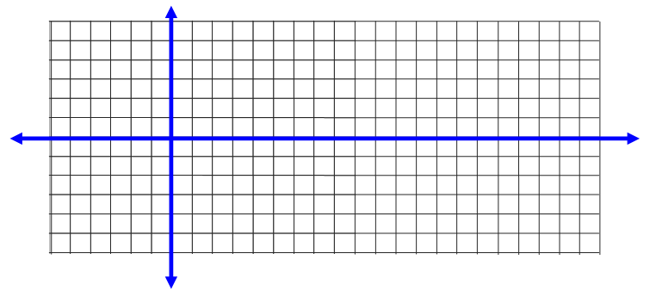

1. Sketch 2 cycles of the graph of a sinusoidal function that has a period of 90, an amplitude of 2, and whose equation of the axis is y = 1.



1. For the function $m\left(x\right)=\sin{(\frac{x}{2}})+2$ $m\left(x\right)=\sin\left(-\frac{x}{2}\right)-$

a) Sketch one cycle of m(x)



b) Complete the table for the function m(x).

|  |  |  |  |  |
| --- | --- | --- | --- | --- |
| Period | Amplitude | Equation of the Axis | Domain of 1 Cycle | Range |
|  |  |  |  |  |

1. For the function $f(x)=3sin⁡(x+30)$: $m\left(x\right)=\sin\left(-\frac{x}{2}\right)-$

a) Sketch one cycle of f(x)



b) Complete the table for the function f(x).

|  |  |  |  |  |
| --- | --- | --- | --- | --- |
| Period | Amplitude | Phase Shift | Domain of 1 Cycle | Range |
|  |  |  |  |  |

1. For the function g $\left(x\right)=-3cos⁡(x-60)$: $m\left(x\right)=\sin\left(-\frac{x}{2}\right)-$

a) Sketch one cycle of g(x)



b) Complete the table for the function g(x).

|  |  |  |  |  |
| --- | --- | --- | --- | --- |
| Period | Amplitude | Phase Shift | Domain of 1 Cycle | Range |
|  |  |  |  |  |

1. Fill in the blanks: When y = sin x transforms to y = 2sin x, the __ coordinate changes, while the __coordinate does not change.
2. A Ferris wheel has a diameter of 30 metres, and the loading platform is 2 metres above the ground. The Ferris wheel completes one revolution every 180 seconds. Create a sinusoidal equation modeling the height, *h(t)*, of the rider above the ground, in metres, as a function of time, *t,* measured in seconds.

1. A snail is riding a water wheel as it turns counter clockwise, and her height above the water is given by the equation *h(t)* = 4cos(2*t*), where *h(t)* is in metres, and *t* is the time, in seconds.

a) Graph the snail’s height above the water as a function of time



b) What is the minimum height of the snail? What does this represent?

c) Calculate the time required for one revolution of the water wheel.

1. At low tide, the water is 4 metres deep. At high tide, the water is 10 metres deep. Each cycle takes 16 hours. Assume the cycle starts at low tide.
2. Create a sinusoidal equation modeling the depth of the water, *d(t)*, in metres, as a function of the time elapsed since low tide, *t*, in hours.
3. Use the equation to calculate the depth of the water 42 hours after low tide.
4. State two possible sinusoidal equations of the function graphed on the grid below (1 sine, 1 cosine).







1. State the transformations (in order) that would be applied to the graph of f(x) = sin x to obtain the graph of

g(x) = 3sin[2(x-45)].

1. State the transformations (in order) that would be applied to the graph of f(x) = cos x to obtain the graph of

$$h\left(x\right)=\sin\left(2x-180\right)+3$$