**Two-Variable Data - REVIEW**

1. Define the following words:

* Correlation
* Interpolation
* Extrapolation

1. A number of people are lined up at the bus stop. They are represented in the graph below. Who is represented by each point on the scatter graph?

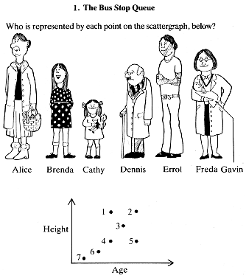

Height

Age

1. 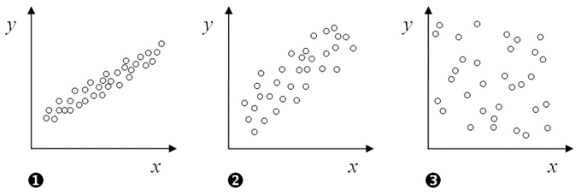For each graph,
2. Does this scatter plot show a positive, a negative, or a no correlation? Explain your reasoning.
3. Label the axis with two variables that could be represented by this graph.
4. Identify which line of best fit represents the data. For all others, explain why they are wrong.

a) 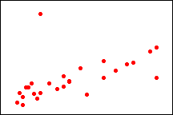 b)  c)  d) 

1. State whether each situation involves one-variable or two-variable data. Also state whether the data is categorical, discrete or continuous.

2

1

* 1. James decides to ask all of his classmates how many different sports they play
  2. Jenny does an experiment to see if there is a relationship between the volume of coffee they drink (in mL) and their marks in math class.
  3. Susan asks students at Newmarket HS which school subject is their favourite.

1. For each of the following sets of data, identify:
2. the Independent variable
3. the dependent variable
4. the correlation, if one exists (strength and direction)
5. Number of air conditioners sold and the average daily summer temperature.
6. Hours spent sleeping and hours spent awake.
7. Number of applications for a job and probability that you will get the job.
8. A person’s weight and the amount of time it takes them to drink 500 mL of water.
9. Number of kilometres driven and total fuel cost of the trip.
10. The Environment Club collected the following data over a two-week period.



|  |  |
| --- | --- |
| Number of  Cans Sold | Number of Cans in Recycling Bin |
| 60 | 55 |
| 87 | 80 |
| 55 | 52 |
| 20 | 18 |
| 100 | 92 |
| 42 | 38 |
| 68 | 60 |
| 90 | 12 |
| 50 | 45 |
| 60 | 56 |

1. Make a well-labeled scatter plot of the data on the grid above (*including title, axes labels, and appropriate scales.*)
2. Circle the “outlier” on your scatter plot.
3. Describe the relationship between the number of cans sold and the number of cans recycled.
4. Sketch a line-of-best-fit on the scatter plot.
5. Algebraically determine the equation of the time of best fit.
6. Using the graphing calculators determine the equation of the line of best fit.
7. Using your graphing calculator equation of your line-of-best-fit, determine how many cans would you expect to be in the recycling bin if 70 cans of pop are sold? Also, indicate this on your graph.