Lesson 5.2 – Linear and Quadratic Models

Goal: Apply linear models to analyze and predict behaviour of real-world situations
Apply quadratic models to analyze and predict behaviour of real-world situations

Tables, graphs, and equations are all examples of _________________________________________________

Linear Models
Represent quantities that increase or decrease by a __________________ amount over ___________ intervals
- In a table of values, the first differences are ____________________
- The graph is a __________________________________
- The equation of the line can be written in the form _____________________, where ______ is the slope and ________ is the vertical intercept (y-intercept)
- The rate of change is ___________________

EXAMPLE 1 Which models represent linear relations?
 | Time (s) Height (m)  0 60  1 55  2 40  3 15 |  | Time (h) Earnings ($)  0 0  5 40  10 80  15 120
 | 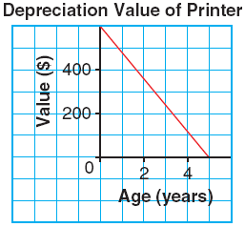 |  | 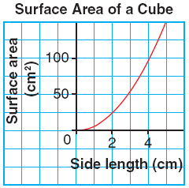
 | 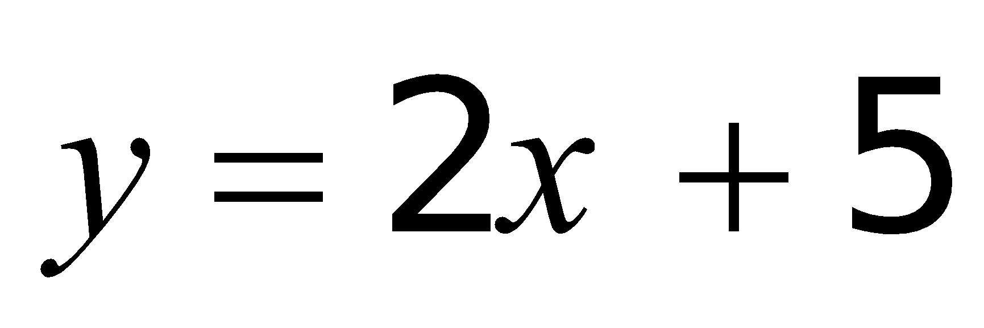 |  | 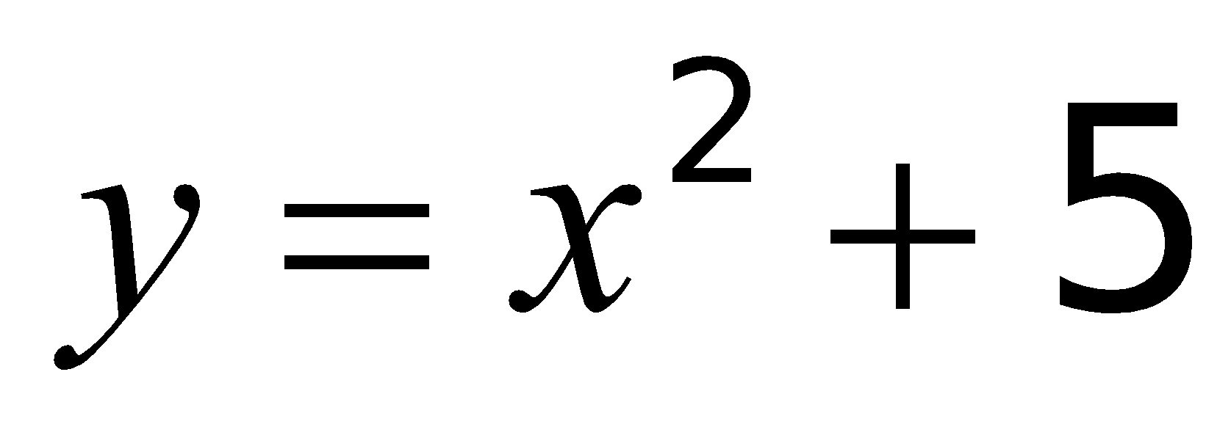

Analyzing Graphs of Linear Relations
In real world graphs of linear relations:
- The vertical intercept represents the ____________________ value of the dependent variable
- The slope represents the _____________________________ in the dependent variable with respect to the independent variable
EXAMPLE 2 A cup of coffee is reheated in a microwave. The temperature, C degrees Celsius, of the coffee after t seconds can be modelled by the following linear equations. Explain what the numbers in the equations represent. How do the two equations compare to each other?
500 W microwave: 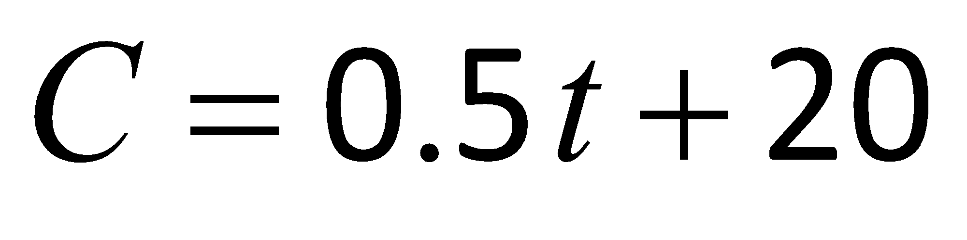 1000 W microwave: 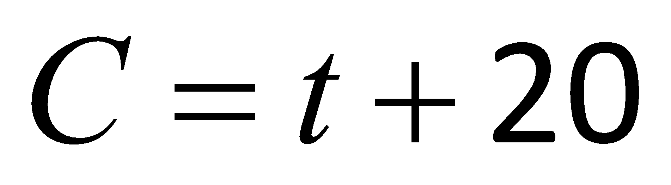

Quadratic Models
Represent quantities that are _____________________ which do not have a _______________ rate of change
- In a table of values, the ___________________ differences are equal
- The graph is a curve called a ___________________________
- The equation has a degree of ______ and is written in the form _____________________ where _____

EXAMPLE 3 Which models represent quadratic relations?
 | h p  0 250  1 238  2 202  3 142 |  | r Q  0 32  1 48  2 72  3 108
 | 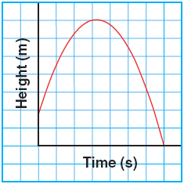 |  | 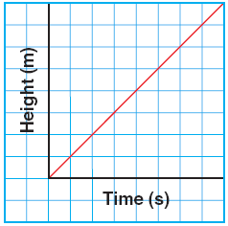
 | 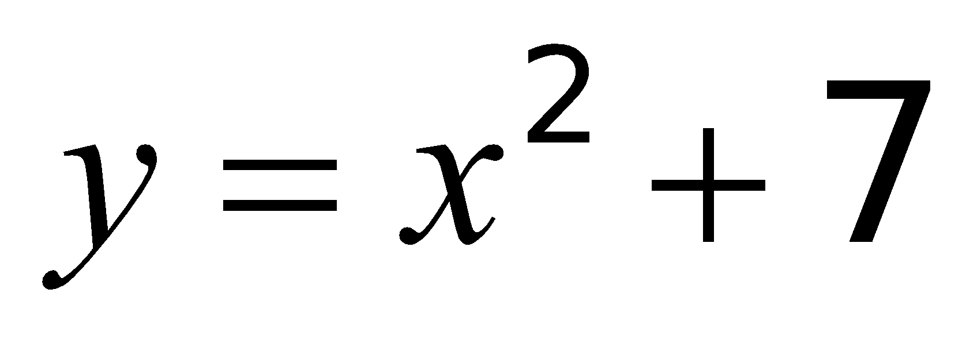 |  | 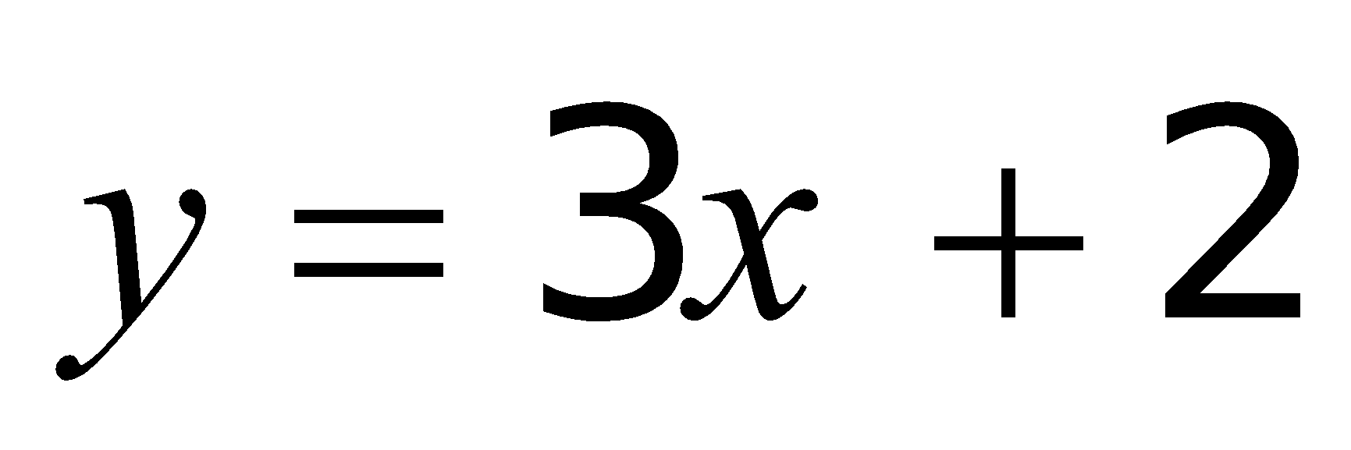
Practice: Page 293 #1 – 6, 10, 11 Page 303 #1 – 3, 7bc

