**Lesson 5.1 – Rate of Change**

***Goal: Calculate and interpret rates of change from a table and a graph***

***Rate of Change (ROC)***: The rate at which something is changing

The ROC is often indicated by the ________________ of a graph

We can determine an average rate of change using a table or graph

|  |  |
| --- | --- |
| **Independent Variable (x)** | **Dependent Variable (y)** |
|  |  |
|  |  |

Table: Graph:

**Average ROC** = _________________________ = ____________

***Calculating and Interpreting Rates of Change***

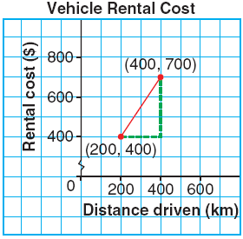***EXAMPLE 1*** Calculate the average rate of change between each pair of points. Explain what the rate of change means.

1. Altitude of an Airplane **b)**

|  |  |
| --- | --- |
| **Time (min)** | **Airplane Height (m)** |
| 0 | 2000 |
| 4 | 1400 |

***F:\Office2007\MEDIA\CAGCAT10\j0212957.wmfComparing Rates of Change***

***EXAMPLE 2*** The distance required to stop a car depends on the speed at which the car is travelling. Use the tables below (showing the reaction distance and breaking distance needed to stop a car on dry pavement for given speed) to answer the following.

|  |  |  |  |  |
| --- | --- | --- | --- | --- |
| **Speed  (km/h)** | **Reaction  Distance (m)** |  | **Speed  (km/h)** | **Stopping  Distance (m)** |
| 0 | 0 |  | 0 | 0.0 |
| 10 | 2 |  | 10 | 0.5 |
| 20 | 4 |  | 20 | 2.0 |
| 30 | 6 |  | 30 | 4.5 |
| 40 | 8 |  | 40 | 8.0 |
| 50 | 10 |  | 50 | 12.5 |

1. Calculate the average rate of change between consecutive points in each table. Describe the rates of change revealed in each table.
2. Graph the data in the tables. Describe how the graph reflects the rates of change across the data.

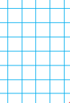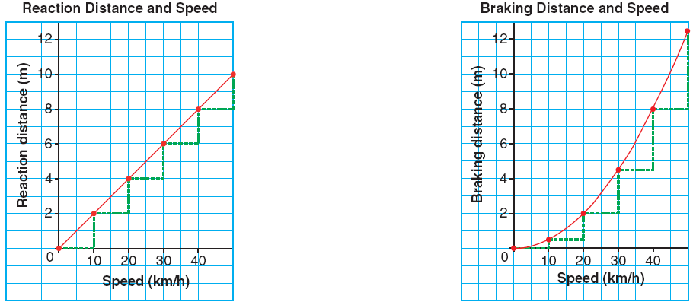

***C:\Users\Vicki\AppData\Local\Microsoft\Windows\Temporary Internet Files\Content.IE5\MK0D7N5K\MC900391486[1].wmfIdentifying Rates of Change in a Table and a Graph***

**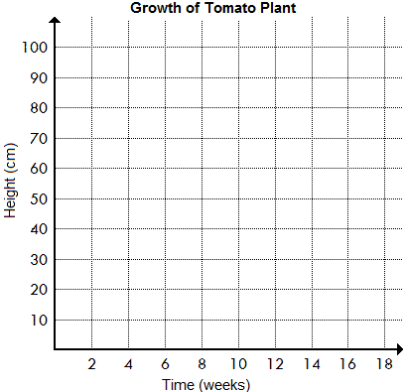*EXAMPLE 3*** The table below shows the change in height of a tomato plant from germination until the tomato ripens.

|  |  |
| --- | --- |
| **Time (wks)** | **Height (cm)** |
| 0 | 0 |
| 2 | 5 |
| 4 | 10 |
| 6 | 20 |
| 8 | 40 |
| 10 | 58 |
| 12 | 75 |
| 14 | 86 |
| 16 | 90 |
| 18 | 90 |

1. Determine when the rate of change in the height is:

i) **Zero**: ii) **Constant**: iii) **Changing**:

1. When is the rate of change in height the greatest?
2. Describe the growth of the plant.

***SUMMARY***

**Practice**: Page 284

#1 – 7, 9, 11

|  |  |  |
| --- | --- | --- |
| **Rate of Change** | **Table** | **Example on Graph** |
| **Zero** | First differences are  _________________ |  |
| **Constant** | First differences are  _________________ |  |
| **Changing** | First differences are  _________________ |  |