Lesson 2.6 – Optimizing Volume and Surface Area
Goal: Determine the optimal volume and surface area for 3-dimensional figures

Optimization: The process of finding the most efficient use of available materials within given constraints.

Key Concepts
- Among all rectangular prisms with a given surface area, a ______________ has the maximum volume
- Among all rectangular prisms with a given volume, a ______________ has the minimum surface area

FORMULAS for CUBE
Volume: Surface Area:
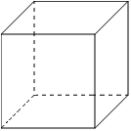

EXAMPLE 1
What dimensions produce a minimum surface area of a rectangular prism with a volume of 1000 cm³?

EXAMPLE 2
What dimensions of a rectangular prism will produce a maximum volume if the surface area is 486 cm²?

Optimizing with Restrictions
There may be constraints on the prism you are optimizing.
- The dimensions may have to be whole numbers or be multiples of a given number.
- Sometimes one or more of the sides of the object are missing or bordered by some physical barrier.
In these cases, the optimal rectangular prism will not be a cube. You can use diagrams or a table and graph to find the dimensions of the optimal rectangular prism.

EXAMPLE 3
Jacob is designing a glass candle holder. It will be a square-based rectangular prism with outer surface area of 225 cm², and no top.
Determine the maximum volume of the candle holder to the nearest cm. What are the dimensions of the candle holder?

Base Side Length (cm) | Height of Prism (cm) | Volume  (cm³) | Surface Area (cm²)
1 |  |  | 225
2 |  |  | 225
3 |  |  | 225
4 |  |  | 225
5 |  |  | 225
6 |  |  | 225
7 |  |  | 225
8 |  |  | 225
9 |  |  | 225
10 |  |  | 225

EXAMPLE 4
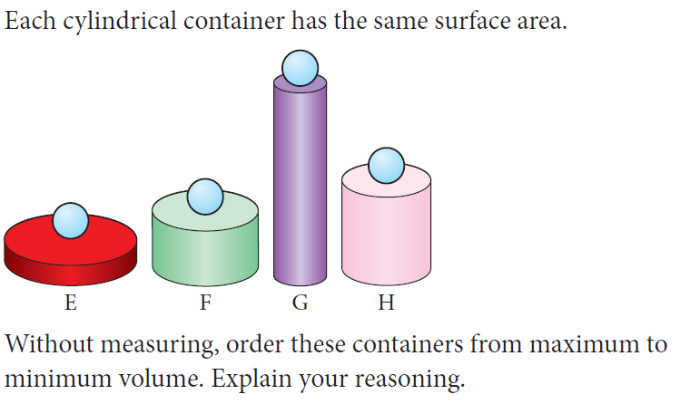
Practice: Page 110 #1-5, 8, 9, 12-16

