**Lesson 2.3 – Working with Composite Objects**

***Goal: Determine the surface area and volume of composite 3-dimensional objects***

***Composite object***: when a structure or object is make up from several simple objects

***Calculating Volume of a Composite Figure***

1. Calculate the volume of each part of the composite object
2. Add the volumes
3. Subtract the volume of any parts that are removed from the object

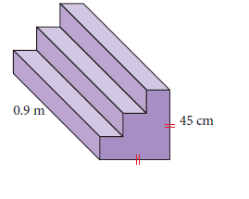

***EXAMPLE***

1. You need to construct a concrete staircase with the dimensions shown.
2. Determine the volume, to two decimal places, of concrete needed.
3. Concrete costs $0.02 per cubic cm. How much will the stairs cost?
4. A machinist drilled a conical hole into a cube of metal as shown. If the cube has sides of length 8 cm, what is the volume of the metal after the hole is drilled? Round to the nearest tenth



***Calculating Surface Area of a Composite Figure***

1. 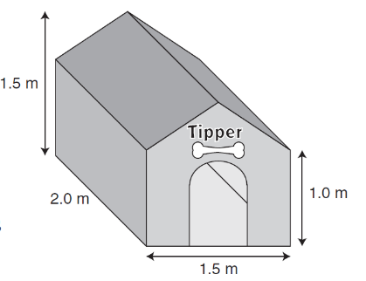Calculate the surface of each “face” that makes up the composite object
2. Add the areas together

***EXAMPLE***

3. John is making a doghouse for his dog, Tipper.

a) What is the surface area of the exterior of the doghouse before the doorway is cut? Include the floor.

|  |  |  |  |  |
| --- | --- | --- | --- | --- |
| **Face** | **Shape** | **Qty** | **Formula** | **Area of each face** |
| Roof panels | Rectangle |  |  |  |
| Triangular panels | Triangle |  |  |  |
| Front/Back | Rectangle |  |  |  |
| Sides | Rectangle |  |  |  |
| Floor | Rectangle |  |  |  |

**b)** The exterior walls and roof of Fido’s house are to be painted. A 40-cm wide doorway has been cut as shown. The doorwayis 60 cm at its highest point. What is the area to be painted?