**Lesson 2.2 – Volume and Surface Area**

***Definitions:***

* Volume: The amount of space occupied by an object Possible Units: _____
* Surface Area: The measure of the area of all the faces of an object. Possible Units: _____

**Example 1: Volume and Surface Area of a Prism**

Determine the amount of chocolate that can fit inside this Toblerone package.

Determine the area of wrapper needed to cover the chocolate

**SOLUTION**:

* Determine the shape _______________________________________
* Calculate the volume:
  + Formula for the volume: V =___________
* Calculate the surface area:
  + Draw the sides of this shape separately (there are 5 sides):
  + Calculate the area of each:
  + Add up the areas:

**Example 2: Volume of a Cylinder**

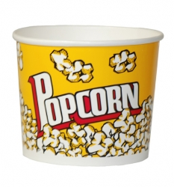Cineplex has just redesigned their popcorn containers. The container is 2ft high, and holds 1.5m³ of popcorn. What is the diameter of the container, to the nearest centimeter?

**Solution:**

Step 1: Convert the height to metres.

1ft = ________m

2ft =

**Step 2:** Substitute the height and volume into the formula for the volume of a cylinder and solve for the radius.

Formula for the Volume of a Cylinder: V = ______________

***Can you find the surface area of the popcorn bucket? (note: there is no top)***

|  |  |
| --- | --- |
|  |  |