Lesson 2.1 – Areas of Composite Shapes

Definitions:

- Perimeter: The distance around a closed figure: Possible Units: _____

- Area: The number of square units needed to cover a surface Possible Units: _____

Example: Find the area and perimeter of each shape:

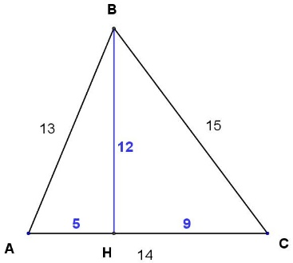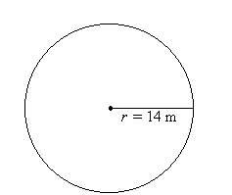

Practice: Find the areas of the following shapes (Use the π button on your calculator)
- A rectangle measuring 5 cm by 12 cm
- A square with side lengths 6 cm
- A parallelogram with base 3 cm and height 2 cm

Can we find the area of this shape?
This is called a composite figure!
