Lesson 1.3 – Obtuse Triangle Investigation
- Learning Goals: Investigate connections between primary trigonometric ratios of acute angles and obtuse angles. Determine the values of the sine ratio, cosine ratio, and tangent ratio for obtuse angles.
Recall
Angles can be divided into three groups based on their measure:

Today we will look at sin, cos and tan ratios for obtuse angles. Can we draw a right triangle with one obtuse angle? Explain.
Instead, we use a Cartesian coordinate system to think about trigonometric ratio:
Two angles are supplementary if they add to 180°
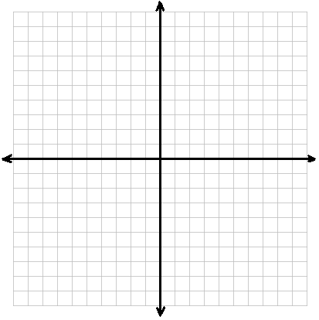

Complete the investigation at http://msrouhani.wikispaces.com/file/view/3025%20Obtuse%20Angles.swf
Complete the worksheet as you answer the questions along the way:
Page 2: Copy down the answers in the table (after you move the point D).
- What do you notice about the values of sin(∠ABD) and sin(∠CBD)?
- What about the values cos(∠ABD) and cos(∠CBD) or the value of tan(∠ABD) and tan(∠CBD)?
Page 3: After completing the activity, copy the answers below
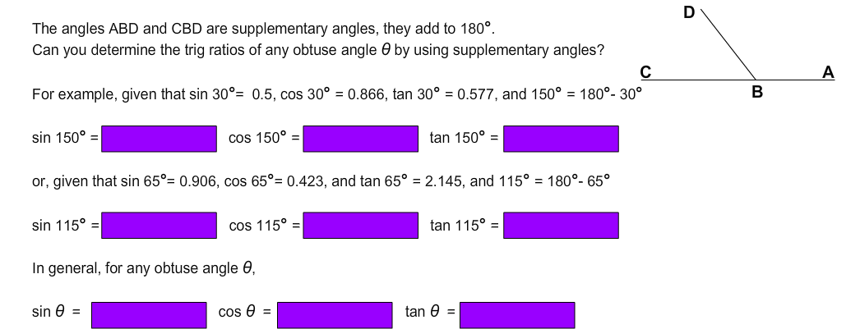

Page 4: After completing the activity, copy the answers below
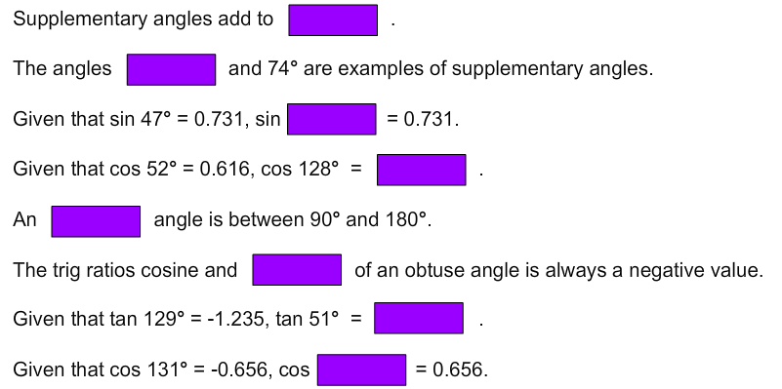

Page 5
What are the coordinates of the point A in this graph? ( _____, _____ )
How do the values of x and y relate to the adjacent and opposite sides of the triangle?

Page 6: Express the trig ratios for the angle θ in terms of x, y, and r

Page 7: Drag point P to form acute angles. Drag the point P to form an obtuse angle.
- What do you notice about the three trig ratios? Why does this occur?

Page 8:
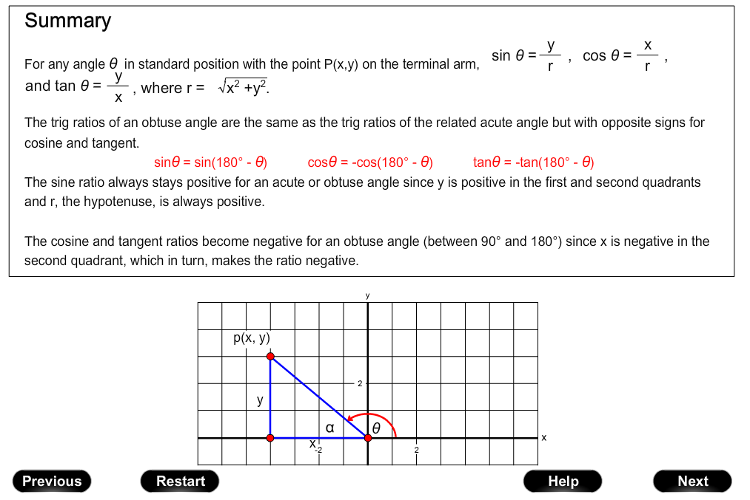
Practice: Continue to complete the rest of the pages in the online activity.

