Lesson 1.2 – Applications of Trigonometric Ratios
- Learning Goal: Determine the unknown sides and angles of an acute right triangle

Example 1: You are tasked at measuring the height of a certain tall building. From 40 meters away you can measure the angle to the top of the building is 70 degrees. Find the height of the building.
70⁰
40 m

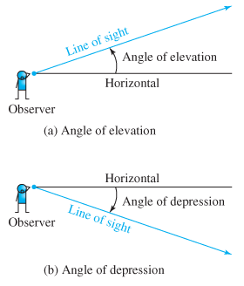
An angle from horizontal looking up at an object is an angle of elevation
An angle from horizontal looking down at an object is an angle of depression

Example 2: An air traffic controller is in a control tower 92 m above the ground. He estimates his angle of elevation to a passing airplane to be 17º. The airplane is approximately 4800 m from the control tower.
- Approximately how high is the airplane above the ground?
- Determine the approximate angle of elevation from the bottom of the control tower to the airplane.
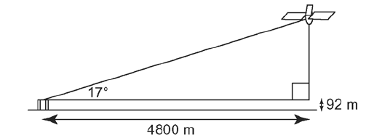

Example 3: A roadway rises 4 m for every 10 m along the road. What is the angle of elevation of the roadway?

Example 4: From the top of a 100 metre cliff, Roger looks at a boat in the lake below. The angle of depression from Roger to the boat is 30°. What is the distance of the boat from the bottom of the cliff?

Example 5:
