Do you Remember?
Pythagorean Theorem
A right triangle is ______________________________________________

The hypotenuse of a right triangle is _______________________________

_____________________________________________________________

The relationship between the sides of a right triangle is: ________________

Examples:

- A right-angled triangle has legs that measure 7.9 cm and 3.2 cm. Calculate the length ofthe hypotenuse.

2.A right-angled triangle has a leg thatmeasures 10.6 mm and a hypotenuse thatmeasures 14.8 mm. Calculate the length ofthe other leg.

- Mr. Patel presented his mathematics class with several triangles.
The side lengths were the following:
Triangle A: 15.3, 20.4, 25.5
Triangle B: 3.1, 4.1, 5.1
Triangle C: 8, 15, 17
Triangle D: 7, 24, 24
Which are right triangles?

Solving Proportions
A ratio is a comparison of two numbers. A proportion is just two ratios that are equal to each other. Be sure that the same units of measurement are in the numerator and the same units of measurement are in the denominator.
Example: There are 149 nurses, 69 doctors, and 230 patients in a hospital.

- Find the ratios (reduce to lowest terms)
- Nurses to doctors:

- Doctors to patients:

- Patients to doctors:

- The hospital is required to have one doctor for every 5 patients and 2 nurses for every 5 patients. What is the minimum number of doctors and nurse that the hospital must have?

Unit Conversions
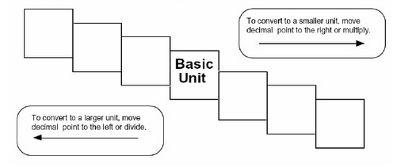

- Convert 3 m to cm 2. Convert 600 mg to g 3. Convert 42 000 km to cm

Many people use the imperial system of measurement. The most common imperial units of length are the inch, foot, yard and mile.
Example: Match each measure with its equivalent
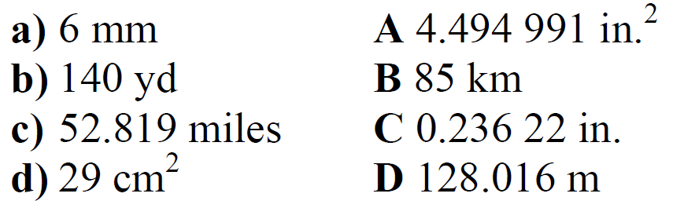

Seatwork: Page 2 #1-3, Page 3 #1-3

