Review For the Final Exam (MPM2D) Name:____________

**As part of your review, I would suggest that you:**

* Write all the Formulas and Definitions used in the course
* Outline the steps needed to complete certain questions
* Complete the suggested review questions
* Redo knowledge and application sections of all tests, quizzes and assignments
* READ your lessons thoroughly

Topics: Checking point on a line

Solving linear systems (graphing, substitution, elimination)

Intersecting/parallel/coincident systems word problems (numbers, money, investments, mixture, speed/distance/time, currents/headwinds/tailwinds)

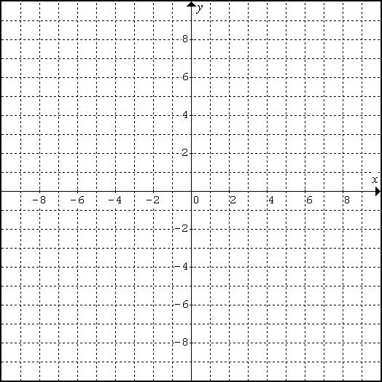

1. Solve by graphing: 
2. Solve using substitution, and check your answer: 
3. Solve using elimination, and check your answer: 
4. Sue invested $5800, part at 7% and the remainder at 9%. After one year, the total interest

earned was $454. How much did she invest at each rate?

1. Nick was counting quarters and dimes. He had 124 coins in all, totalling $19.60. How many of each coin did he have?
2. Thomas has two part-time jobs delivering flyers. He earns $9/h at his weekend job and $12/h at his weekday job. Last week, he worked 23 hours and earned a total of $231. How many hours did Thomas work at each job?
3. Coffee that sells for $3.60/kg is blended with coffee that sells for $2.40/kg to make 2 kg of coffee that sells for $2.70/kg. How much of each type of coffee was used?

**Suggested review from the textbook: Page 156 #1ac, 2, 4, 5, 6**

Topics:

* Midpoint of a line segment
* Length of a line segment
* Equations of lines
* Applying slope, midpoint, length
* Equation of a circle
* Properties of triangles
* Properties of quadrilaterals
* Properties of circles

1. The endpoints of a line segment are A(-4, 3) and B(5, -2). Calculate:
   1. The length of AB b. The midpoint of AB c. The slope of AB
2. Find the equation of the line that passes through the points in question 1.
3. Determine the equation of the following circles:
   1. Centre (0, 0) and radius 4 b. Centre (0, 0) and through (3, 4)
4. Determine whether the point (1, -9) is inside, outside, or on the circumference of the circle x2 + y2 = 100.
5. Line segment AB has endpoints A(3, -7) and B(-9, -5). Determine the equation of the perpendicular bisector of AB.
6. ∆PQR has vertices P(4, -3), Q(-2, -7) and R(-4, -4).
   1. Classify the triangle as scalene, isosceles, or equilateral.
   2. Determine the equation of the median from vertex R?
7. Verify that the quadrilateral with vertices K(-1, 0), L(1, -2), M(4, 1) and N(2, 3) is a rectangle.

**Suggested review from the textbook: Page 156# 7, 9, 11ac, 15 & Page 439 # 12**

Topics:

* Multiplying polynomials
* Special products
* Common factors
* Factoring trinomials
* Factoring difference of squares
* Factoring perfect square trinomials

1. Expand and simplify each:
   1.  b. 
2. Factor completely:
   1.  b. 

c.  d. 

e.  f. 

g.  h. $25x^{2}-20x+4$

**Suggested review from the textbook: Page 320# 8, 9, 11, 12**

Topics:

* Transformations of quadratics
* Graph 
* Quadratic relations in the form 
* Maxima and Minima
* Solving quadratic equations
* Solving quadratics using x-intercepts
* The quadratic formula
* Solve problems using the quadratic equations



1. For each parabola, state the following and graph:

|  |  |  |
| --- | --- | --- |
|  |  |  |
| 1. direction of opening |  |  |
| 1. the vertex |  |  |
| 1. step pattern |  |  |
| 1. the axis of symmetry |  |  |
| 1. the max or min value |  |  |
| 1. the transformations |  |  |

1. Determine if each forms a linear or quadratic relationship or neither.
   1. b.

|  |  |
| --- | --- |
| **x** | **y** |
| 2 | -5 |
| 3 | -11 |
| 4 | -17 |
| 5 | -23 |

|  |  |
| --- | --- |
| **x** | **y** |
| 0 | 7 |
| 1 | 9 |
| 2 | 15 |
| 3 | 25 |

1. Determine the equation of the parabola with vertex at (-8, 1) passing through the point (-1, -48).

1. Solve by factoring:
   1.  b. 

c.  d. 

1. Solve using the quadratic formula. Round to 2 decimal places if necessary.

|  |  |  |
| --- | --- | --- |
|  |  |  |

1. Determine the vertex by completing the square.
   1.  b. *y* = -*x*2 – 6*x* + 1
2. Determine the vertex by factoring/averaging the zeros.
   1.  b. 
3. The height of a golf ball after being hit is described by , where *h* metres is the height, *t* seconds after the ball has been hit.
   1. Is this ball being hit from the ground or on a tee? How do you know?
   2. What is the maximum height of the ball?
   3. How many seconds after impact is the maximum height reached?
   4. When does the ball hit the ground?
   5. For how long is the ball over a height of 10 m? Round to one decimal place.
4. The revenue, $R$, from concert ticket sales at a local venue is calculated as $(number of tickets sold)×(price of ticket)$. The current price of a ticket is $\$20$, and the venue typically sells $100$ tickets. For each $\$1$ decrease in ticket price, $10$ more tickets are sold.
   1. Write an equation to model the Revenue.
   2. What is selling price that will maximize the Revenue? Determine the maximum Revenue.
   3. Find the selling price of each ticket if the Revenue was $2,090.

**Suggested review from the textbook: Page 320 #2, 3bc, 15, 16, 17ac, 19ad, 20, 21**

Topics:

* Similar triangles
* The Tangent, Sine and cosine ratios
* Solving problems using two right triangles
* The sine law
* The cosine law

1. Determine the length of the indicated side to the nearest tenth and the angle to the nearest degree.



B

A

C

11cm

θ = ?

17cm

B

A

C

b=?

33**°**

19cm

a. b. c.

d. e.

62



i

47



9cm

B

I

G

****

4.8 m

3 m

39



N

A

T

.

****

18 cm

7 cm

13 cm

A

H

G

f. g.

8.5cm

59°

t

9lude a well labeled diagram.B(1,-3) and C(-3,3). Plot the points on the Cartesian Plane below and find the measure of each

M

A

T

1. Use the measurements given in the diagram to find the height of the building.

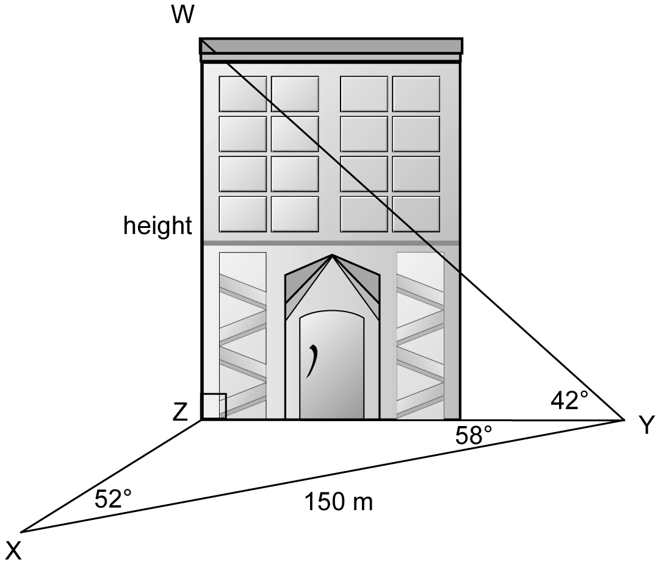

**Suggested review from the textbook:**  Page 434#2, 3a, 4, 5, 7, 8, 9, 10, 11, 12, 14, 15

***FINAL COURSE REVIEW***

Page 438# 3a, 4d, 5, 9, 11, 14, 19b, 20, 24, 25a, 36c, 37, 42acdf, 44acf,

45bef, 46, 48abc, 49ade, 53b, 55bd, 56abc, 60ac, 66, 68, 69, 75, 77, 80