***(Warm-Up)* Task B: The Basic Parabola *y* = *x*2**

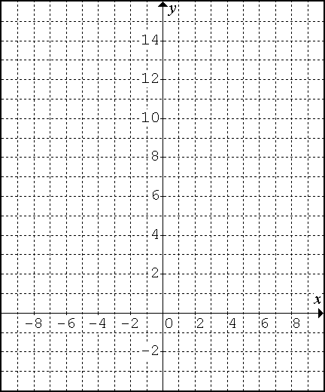

|  |  |  |
| --- | --- | --- |
| ***x*** | ***y* = *x*2** | **first differences** |
| -4 |  |
|  |
| -3 |  |
|  |
| -2 |  |
|  |
| -1 |  |
|  |
| 0 |  |
|  |
| 1 |  |
|  |
| 2 |  |
|  |
| 3 |  |
|  |
| 4 |  |
|  |
| *These are also referred to ↑*  *as the ‘****step pattern****’.* |  |  |
|  |  |  |

1. Complete the table of values, including the first differences.
2. Graph the parabola.

* **Go to DESMOS and type y = (x - h)2 +k. Then click all to add slider. Set h and k to 0.**

**Does this graph match the one you drew above?**

**Task k: What happens when you graph y = *x*2 + *k*?**

* Change the slider for ***k*** to 2. What equation does that produce? ____________________

1. Describe the effect this had on the graph.
2. Complete the following information.

|  |  |  |  |  |  |  |  |  |  |  |  |  |  |  |  |  |  |  |  |  |  |  |  |  |  |  |  |  |  |
| --- | --- | --- | --- | --- | --- | --- | --- | --- | --- | --- | --- | --- | --- | --- | --- | --- | --- | --- | --- | --- | --- | --- | --- | --- | --- | --- | --- | --- | --- |
|  | |  |  |  | | --- | --- | --- | | ***x*** | ***y* = *x*2 + 2** | **first diff.** | | -3 |  | |  | | -2 |  | |  | | -1 |  | |  | | 0 |  | |  | | 1 |  | |  | | 2 |  | |  | | 3 |  | |  | |  |  |  | | **vertex = ________________**  **axis of symmetry = _______**  **direction of opening = _____**  **step pattern =**  **____ ____ ____ ____** |

* Change the slider for ***k*** to -6. What equation does that produce? ___________

1. Describe the effect this had on the graph.

1. Complete the following information.

|  |  |  |  |  |  |  |  |  |  |  |  |  |  |  |  |  |  |  |  |  |  |  |  |  |  |  |  |  |  |
| --- | --- | --- | --- | --- | --- | --- | --- | --- | --- | --- | --- | --- | --- | --- | --- | --- | --- | --- | --- | --- | --- | --- | --- | --- | --- | --- | --- | --- | --- |
|  | |  |  |  | | --- | --- | --- | | ***x*** | ***y* = *x*2 – 6** | **first diff.** | | -3 |  | |  | | -2 |  | |  | | -1 |  | |  | | 0 |  | |  | | 1 |  | |  | | 2 |  | |  | | 3 |  | |  | |  |  |  | | **vertex = ________________**  **axis of symmetry = _______**  **direction of opening = _____**  **step pattern =**  **____ ____ ____ ____** |

1. State the equation of each graph.

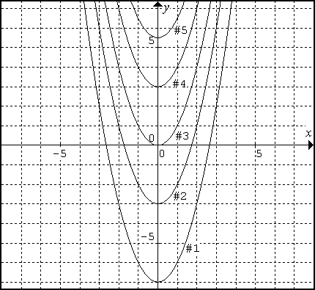#1:

#2:

#3:

#4:

#5:

|  |
| --- |
| **The Effect of k**  The graph of  produces a **vertical translation (or shift)**.   * the parabola will shift __ __ if ***k*** > 0 (i.e: ) * the parabola will shift __ __ __ __ if ***k*** < 0 (i.e: ) |

**Task H: What happens when you graph y = (*x* – h) 2?**

* Back in **DESMOS**; change the slider for ***k*** back to 0.
* Change the slider for ***h*** to -5. What equation does that produce in **vertex form**? (HINT: Sub -5 for h)

_________________

1. Describe the effect this had on the graph.

1. Complete the following information:

|  |  |  |  |  |  |  |  |  |  |  |  |  |  |  |  |  |  |  |  |  |  |  |  |  |  |  |  |  |  |
| --- | --- | --- | --- | --- | --- | --- | --- | --- | --- | --- | --- | --- | --- | --- | --- | --- | --- | --- | --- | --- | --- | --- | --- | --- | --- | --- | --- | --- | --- |
|  | |  |  |  | | --- | --- | --- | | ***x*** | ***y* = (*x* + 5)2** | **first differences** | | -8 |  | |  | | -7 |  | |  | | -6 |  | |  | | -5 |  | |  | | -4 |  | |  | | -3 |  | |  | | -2 |  | |  | |  |  |  | | **vertex = ________________**  **axis of symmetry = _______**  **direction of opening = _____**  **step pattern =**  **____ ____ ____ ____** |

* Back in **DESMOS**; change the slider for ***h*** to 4.

What equation does that produce in **vertex form**? _________________

1. Describe the effect this had on the graph.

1. Complete the following information:

|  |  |  |  |  |  |  |  |  |  |  |  |  |  |  |  |  |  |  |  |  |  |  |  |  |  |  |  |  |  |
| --- | --- | --- | --- | --- | --- | --- | --- | --- | --- | --- | --- | --- | --- | --- | --- | --- | --- | --- | --- | --- | --- | --- | --- | --- | --- | --- | --- | --- | --- |
|  | |  |  |  | | --- | --- | --- | | ***x*** | ***y* = (*x* – 4)2** | **first differences** | | 1 |  | |  | | 2 |  | |  | | 3 |  | |  | | 4 |  | |  | | 5 |  | |  | | 6 |  | |  | | 7 |  | |  | |  |  |  | | **vertex = ________________**  **axis of symmetry = _______**  **direction of opening = _____**  **step pattern =**  **____ ____ ____ ____** |

1. State the equation of each graph.

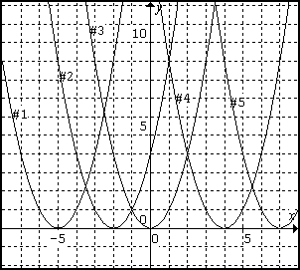 #1: ____________________________________

#2: ____________________________________

#3: ____________________________________

#4: ____________________________________

#5: ____________________________________

|  |
| --- |
| **The Effect of h**  The graph of  produces a **horizontal translation (or shift)**.   * the parabola will shift __ __ __ __ __ if ***h*** > 0 (i.e:  or )      * the parabola will shift __ __ __ __ if ***h*** < 0 (i.e:  or ) |

**Task T: What happens when they’re together *y* = (*x* – h)2 + k?**

* Back in **DESMOS**, change the slider for ***k*** to 1 and for ***h*** to -3.

What equation does that produce in **vertex form**? _________________

1. Describe the effect this had on the graph.
2. Complete the following information:

|  |  |
| --- | --- |
|  | **vertex = ________________**  **axis of symmetry = _______**  **direction of opening = _____**  **step pattern = ____ ____ ____ ____** |

15. Graph the equation y = (x - 2)2+ 3 using the step pattern.

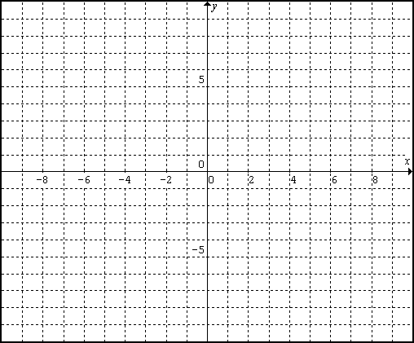

**Graphing: Step Pattern**

**1) State the step pattern:**

**2) Plot the vertex**

**3) From vertex, move 1 unit right, then 1 unit up. Plot the point. (This is your first step)**

**4) From the last point, move 1 unit right, then 3 units up. Plot the point. (This is your second step)**

**5) If there is any space left in the Cartesian plane, continue with this pattern.**

**Task P: Practice!**

1. Complete the following table.

|  |  |  |  |  |
| --- | --- | --- | --- | --- |
| **Equation** | **Vertex** | **Axis of Symmetry** | **Step Pattern From Vertex** | **Direction of Opening** |
| 1)*y* = *x*2 + 1 |  |  |  |  |
| 2) *y* = *x*2 ______ | (0, -6) |  |  |  |
| 3) *y* = (*x* – 4)2 |  |  |  |  |
| 4) *y* = (*x* ______ )2 |  | *x* = -7 |  |  |
| 5)*y* = (*x* + 4)2 - 2 |  |  |  |  |
| 6) | (1, -3) |  | 1, 3, 5, 7 | Up |

1. Graph each parabola from the table.

|  |  |  |
| --- | --- | --- |
| *1) y* = *x*2 + 1 | *2) y* = *x*2 ______ | *3) y* = (*x* – 4)2 |
|  |  |  |
|  |  |  |
| *4) y* = (*x* ______ )2 | *5) y* = (*x* + 4)2 - 2 | 6) _______________ |
|  |  |  |

Homework: p. 178 #1-3, 6-8