|  |
| --- |
| Open: **DESMOS** Graphing Calculator  **download.jpg** |

**Task 1: Let’s Review Linear Relationships**

Billy Bob’s dog is out for a walk. The equation to model its distance away from the house, *d* metres, after *t* seconds is: .



* Enter this equation into **DESMOS**.
* Adjust your screen to show the scales like they are shown in the grid below.

1. Complete the Distance column in the table below. To calculate the distances, you can:
   * You can use the equation above and your calculator.
   * You can use the TRACE feature on the online graphing calculator.

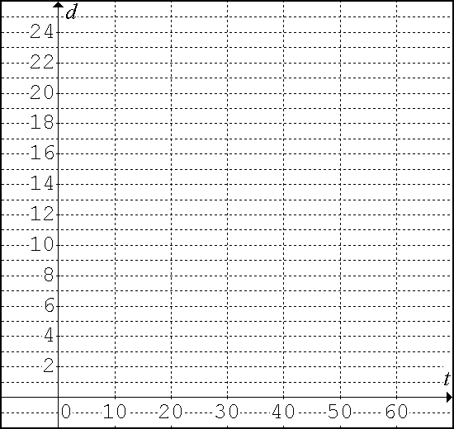

|  |  |  |
| --- | --- | --- |
| Time  (sec) | Distance  (m) | *Finite Differences* |
| First Differences |
| 0 |  |
|  |
| 10 |  |
|  |
| 20 |  |
|  |
| 30 |  |
|  |
| 40 |  |
|  |
| 50 |  |
|  |
|  |  |  |

1. Graph the relation on the grid.
2. a. How far from the house is the dog when he starts his walk? This is the **y-intercept**. ___________

Please label this point on the graph.

b. At what rate does the dog walk? This is the **slope**. ___________

Please indicate this on the graph with a rate triangle.

1. Calculate the **first differences**? Do you remember how?
2. The first differences are all equal. What does that tell you about the relationship between *d* and *t*?

**Task 2: Quadratic Relations** *Now, let’s kick it up a notch!!!*

Billy Bob’s dog is now going to run, fetch a frisbee, and then run back. The equation to model

the distance, *d* metres, the dog is away from Billy Bob after *t* seconds is: .

* **Enter this equation in the online graphing calculator.**

1. Complete the Height column in the table below. To calculate the height, you can:
   * You can use the equation above and your calculator.
   * You can use the TRACE feature on the online graphing calculator.



|  |  |  |  |
| --- | --- | --- | --- |
| Time  (s) | Height (m) | *Finite Differences* | |
| First Differences | Second Differences |
| 0 |  |
|  |
| 10 |  |  |
|  |
| 20 |  |  |
|  |
| 30 |  |  |
|  |
| 40 |  |  |
|  |
| 50 |  |  |
|  |
| 60 |  |  |
|  |

1. Graph the relation on the grid.
2. a. How far is the dog from Billy Bob when he starts running? This is the **y-intercept**. __________

b. What is the **maximum** distance between the dog and Billy Bob? This is the **vertex**. __________

c. This shape is called a **parabola**. Draw a vertical line through the vertex of the parabola. This is

the **axis of symmetry**.

d. Would you say that this parabola ‘**opens up**’ or ‘**opens down**’? __________

e. When is the dog 0m away from Billy Bob? These are the **zeros**! (aka: x-intercepts). __________

1. On the graph, label and calculate the following:
2. y-intercept b. vertex c. axis of symmetry d. zeros

1. Calculate the first differences.
2. The first differences are not equal. What does that tell you about the relationship between *d* and *t*?
3. Calculate the second differences. You do this by calculating the first differences of the first differences.
4. The second differences are equal. This means that the relationship is ________________.
5. How does the equation of a Linear Relation compare to the equation of a Quadratic Relation?

|  |  |  |
| --- | --- | --- |
|  | **Linear** | **Quadratic** |
| **general equation** |  |  |
| **shape** |  |  |
| **equations** | slope/y-intercept:  slope/point:  standard: | standard:  vertex: |
| **degree** |  |  |
| **finite differences** | |  |  |  | | --- | --- | --- | | **x** | **y** | *finite diff.* | | **1st Diff.** | | -3 |  | |  | | -2 |  | |  | | -1 |  | |  | | 0 |  | |  | | 1 |  | |  | | 2 |  | |  | | 3 |  | |  |   first differences are ________________ | |  |  |  |  | | --- | --- | --- | --- | | **x** | **y** | *finite differences* | | | **1st Diff.** | **2nd Diff.** | | -3 |  | |  | | -2 |  |  | |  | | -1 |  |  | |  | | 0 |  |  | |  | | 1 |  |  | |  | | 2 |  |  | |  | | 3 |  |  | |  |  |   first differences are ________________  second differences are ________________ |
| **direction** | if first differences are + = _______  if first differences are - = _______ | if second differences are + = _______  if second differences are - = _______ |
| **graph** |  |  |
| **key properties** | y-intercept:  slope: | y-intercept:  zeros (x-intercepts):  vertex: max/min  direction of opening:  axis of symmetry: |
| **example** | |  |  |  | | --- | --- | --- | | **x** | **y** | *finite diff.* | | **1st Diff.** | | -3 |  | |  | | -2 |  | |  | | -1 |  | |  | | 0 |  | |  | | 1 |  | |  | | 2 |  | |  | | 3 |  | |  |     slope = _______________  y-intercept = _______________ | |  |  |  |  | | --- | --- | --- | --- | | **x** | **y** | *finite differences* | | | **1st Diff.** | **2nd Diff.** | | -3 |  | |  | | -2 |  |  | |  | | -1 |  |  | |  | | 0 |  |  | |  | | 1 |  |  | |  | | 2 |  |  | |  | | 3 |  |  | |  |  |     y-intercept = _______________  zeros (x-intercepts) = _______________  vertex = _______________  max/min = _______________  direction of opening = _______________  axis of symmetry = _______________ |

|  |  |  |  |  |  |  |  |
| --- | --- | --- | --- | --- | --- | --- | --- |
| ***Examples:*** | | **A** | | **B** | | **C** | |
|  |  | |  | |  | |
| state & label the zeros | |  |  | |  | |
| state & label the y-intercept | |  |  | |  | |
| state & label the vertex | |  |  | |  | |
| draw in the axis of symmetry & state the equation | |  |  | |  | |
| Does the parabola open up or down? | |  |  | |  | |
| Is the vertex a max or a min? | |  |  | |  | |
| finite differences | | first differences are unequal  second differences are equal  and _______________  *(positive or negative?)* | first differences are unequal  second differences are equal  and _______________  *(positive or negative?)* | | first differences are unequal  second differences are equal  and _______________  *(positive or negative?)* | |