Solving 3D Trigonometric Problems
3 Dimensional problems can be solved using a combination of :
- Trigonometric Ratios
- Sine Law
- Cosine Law
- Pythagorean Theorem
Strategy :
- Create a diagram
- Determine any unknown angles using facts about parallel lines, interior angles in a triangle, etc .
- Add new information to your original sketch
- Use trig to solve the problem
Ex1. When flying in a plane over Prince Edward Island it is possible to see all the way across the island from one side to the other. The pilot of small plane spots the western edge of the island at an angle of depression of 61º and the eastern edge of the island with an angle of depression of 3º. If the plane is flying at an altitude of 10.5km, how long is Prince Edward Island?

Ex2. From point B, Manny uses a clinometer to determine the angle of elevation to the top of a cliff as 38°. From point D, 68.5m away from Manny, Joe estimates the angle between the base of the cliff, himself, and Manny to be 42°, while Manny estimates the angle between the base of the cliff, himself, and his friend Joe to be 63°. What is the height of the cliff to the nearest tenth of a metre?
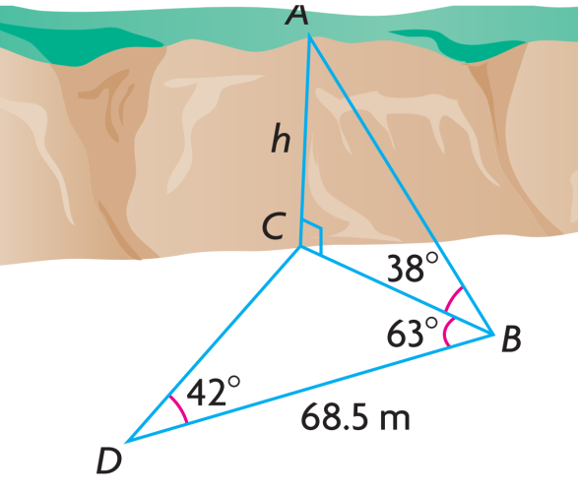

Ex3. Emma is on a 50m high bridge and sees two boats anchored below. From her position, boat A has a bearing of 230° and boat B has a bearing of 120°. Emma estimates the angles of depression to be 38°for boat A and 35° for boat B. How far apart are the boats to the nearest meter?
Bearing : Clockwise angle from NORTH .

