Exit Card

- Complete the table for each of the following

 | Parent  Function | Amplitude | Max value | Min Value | k | Phase shift | Axis of Curve | Equation
a) | sinx |  |  |  |  |  |  | y = ½ sin(x-45) + 2
b) | cosx | 3 |  |  | 2 | 90 right | y=2
c) | sinx |  |  | -4 | ½ | None | y=-2
d) | cosx |  | 6 | -2 | 1 | 45 right

- The function shown is periodic.
Amplitude =

Period =

f(4)=

f(898)=

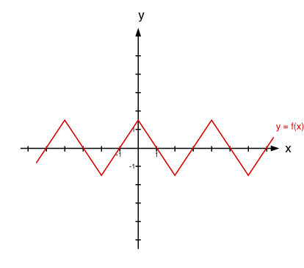

- Describe the following transformations for$y= -10sin⁡[3\left(x-60°\right]+ 8$ with respect to
$y = sinx$.

a. Amplitude: ______________________ b. Period: ___________________________

- Axis of Curve: _________ d. Phase shift:________________________

- Max: ___________________________ f. Min:________________________
- Graph the following equation: y = 3cos (2x – 360) + 2

- Given $y =3\sin\left[4\left(x-45\right)\right]+ 10$,determine the amplitude, period, maximum, minimum and graph the function on the grid provided. Assume $-90≤x≤90$.

- Given $y =-2\cos{(2x)}- 5$,determine the amplitude, period, maximum, minimum and graph the function on the grid provided. Assume $0≤x≤360$.

- A Ferris wheel has radius of 7m. The centre of the wheel is 8 m above the ground. The Ferris wheel rotates at a constant speed of 15°/s. The height above the ground of the only red seat can be modeled by the function $h\left(t\right)=7\sin\left(15°t\right)+ 8$. (1 + 2 + 2 = 5 marks)

- What is maximum height during the first rotation?

- When is the red seat at its maximum height c. How long will take for the red seat to complete
during the first rotation? two full rotations?

- State the transformations in a correct order for the following equation. (5 marks)
$y=\frac{1}{2}sin⁡(\frac{1}{3}x-30)+2$

- Determine the equation of the function $y = 3sin⁡[2(x-30)] +1$ if:

  - the function is further stretched vertically by 2 and shifted 30 degrees right.

  - the function is further stretched horizontally by 3 and shifted 2 units up.

  - the function is further stretched horizontally by 1/4, vertically by 2.

