5.1: Primary and Reciprocal Ratios
Right Angle Triangles
From a given angle, we can name the sides of a right angle triangle:

Adjacent is the side that touches the angle. Opposite is the side that does not touch the angle.

*Note: The opposite and adjacent sides depend on the angle! If we look at the same triangle but a different angle, the opposite and adjacent sides will be different, but the Hypotenuse always stays the same!

Primary Trigonometric Ratios

In a right triangle, the angles and the lengths of sides are related by certain ratios:

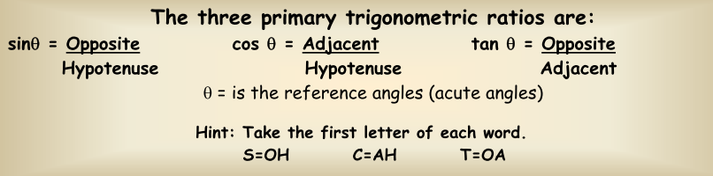

“Solve” a triangle means find the missing angles and sides. Use your math tools:
Trig ratios SOH CAH TOA, Pythagorean Theorem ___________________
Sum of Angles in a Triangle is ______

Example 1: For the triangle below, find x
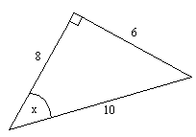
a) sin x b) cos x c) tan x

Example 2: Find the side length
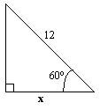

Primary Trig ratios
$\sin{θ} =\frac{opp}{hyp}$ $\cos{θ}=\frac{adj}{hyp}$ $\tan{θ} =\frac{opp}{adj}$

Reciprocal Trig Ratios

$\text{cosecant} θ=\frac{1}{\sin{θ}}$ $\text{secant} θ=\frac{1}{\cos{θ}}$ $\text{cotangent} θ=\frac{1}{\tan{θ}}$

Calculators don’t have reciprocal trig buttons, so if you to evaluate $\sec{20°}$ = $\frac{1}{\cos{20°}}$

Example 3:
a) Determine csc $θ$, sec $θ$and cot $θ$
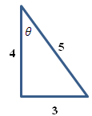

b) Calculate $θ$ to the nearest degrees.

Example 4: Solve the triangle. (ROUNDING: Angles nearest degree, Sides one decimal place)
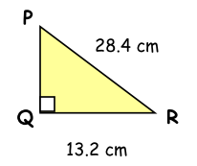

Reciprocal Trig Ratios

- Find csc B.

a) sin B = 0.9781 b) sin B = 0.4067 c) B = 37° d) B = 103°

- Find sec C.

a) cos C = 0. 4848 b) cos C = 0.9272 c) C = 81° d) C = 112°

- Find cot D.

a) tan D = 2.0503 b) tan D = 0.2493 c) D = 42° d) D = 121°

- Find the desired ratios.
a) sin A b) cos B
29
A
C
B
21
20

c) csc A d) sec A

e) csc B f) cot B

- From #4, what do you notice about sin A and cos B? What do you notice about sec A and csc B? Will this always be true? Why or why not?

Solutions:
1. a) 1.0224 b) 2.4588 c) 1.6616 d) 1.0263 2. a) 2.0627 b) 1.0785 c) 6.3925 d) –2.6695
3. a) 0.4877 b) 4.0112 c) 1.1106 d) –0.6009 4. a) 21/29 b) 21/29 c) 29/21 d) 29/20 e) 29/20 f) 21/20
5. they are the same, same, yes

Homework: Handout, p. 280 #1,2,4,5iv,6,8b,9,10, 14,15

