Trigonometry in the Workplace
Trigonometry means "triangle measure". Any profession that deals with measurement deals with trigonometry as well.

Architect: Trigonometry is especially useful in architecture because it allows the architect to calculate distances and forces related to diagonal elements.

Radiologist: Radiologists use trigonometry in the medical field through medical imaging through CAT scans and ultrasounds.
Navigator: Navigators use trigonometry to determine locations, to chart paths, or to determine how far a ship or a plane is away from land.
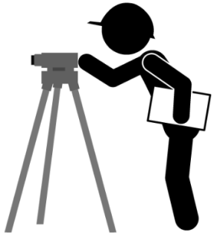
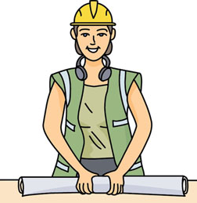
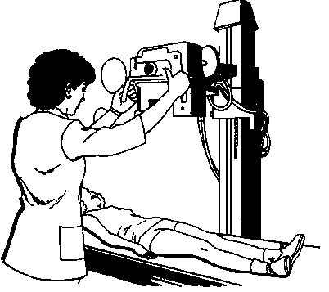
Land Surveyor: Surveyors use the tangent function often to figure out the distance across a river or a canyon to figure out the total distance surveyed

ANGLE OF ELEVATION and DEPRESSION
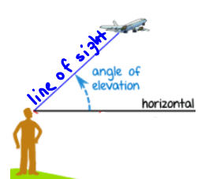  The angle of elevation (of the person) is always measured from the horizontal to line of sight up. | 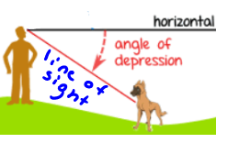  The angle of depression (of the person) is always measured from the horizontal to ‘line of sight’ down.
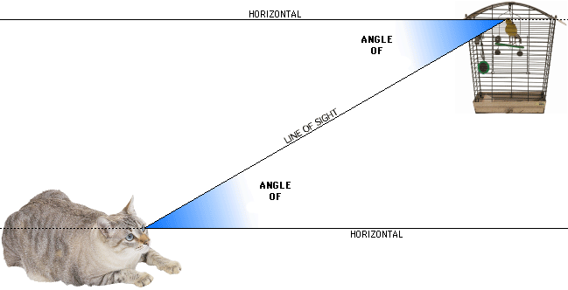
Label the angles.

Included with your solution, draw the pictures presented by the information in the problem. Remember -- you’re dealing with right triangles!
- The angle of elevation of the top of a building from a point 100 feet away from the building is 65º. How tall is the building? (214.5 ft)

- A new tree is supported by a wire. It is secured on the ground at a point 4 ft away from the base of the tree. If the wire makes a 50º angle with the ground, how long is the wire? (6.2 ft)

- The Sears Tower stands 1,451 feet tall. A person across the street is 30 feet away from the foot of the tower. What is the angle of elevation to the top of the tower? (89º)

- An airplane must fly 5.4 miles to get to the airport. The distance along the ground from the airplane to an airport is 5 miles. What is the angle of depression from the plane to the airport? (22º)

- A bird sits on top of a 15-foot lamppost. The angle of depression from the bird to the feet of an observer standing away from the lamppost is 35º. How far would the bird have to fly to get to the observer’s feet? (26.1 ft)

- The angle of depression of a buoy from a point on a lighthouse 100 feet above the surface of the water is 3º. How far is the buoy to the bottom of the lighthouse? (1908 ft)

- A kite is 32 m above the ground. The angle the kite string makes with the ground is 39º. Determine the length of the kite string to the nearest metre. (50.8 m)

- If a plane that is cruising at an altitude of 30,000 feet wants to land at Bush Field, it must begin its descent so that the angle of depression to the airport is 7°. How far would the plane have to fly to get to the airport? (246165.3 ft)

- From the top of a 35 meter cliff, Lori spots a hiker at an angle of depression of 62°. How far is the hiker from the base of the cliff? (18.6 m)

- Josee wanted to measure the depth of the sink hole that opened on Amelia Avenue this morning. She measured the angle of depression to the lowest point to be 35°. She also measured the distance across the sinkhole to be 38 feet. (26.6 ft)

