**Remember the MAPPING NOTATION:**

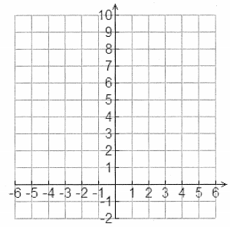



**Graph:**

|  |  |  |
| --- | --- | --- |
| $$\left(x,y\right) → (\frac{x}{k}+d, ay+c)$$ |  | b) |
|  |  | |
|  |  | Asymptote:  y-intercept:  Domain:  Range: |

|  |  |
| --- | --- |
|  | EXTRA PRACTICE |

Now graph these, trying to notice some tips/tricks.

|  |  |  |
| --- | --- | --- |
|  |  |  |
| cart2.PNG | cart2.PNG | cart2.PNG |
|  |  |  |
| cart2.PNG | cart2.PNG | cart2.PNG |
| Asymptote:  y-intercept:  Domain:  Range: | Asymptote:  y-intercept:  Domain:  Range: | Asymptote:  y-intercept:  Domain:  Range: |
|  |  |  |
| cart2.PNG |  | cart2.PNG |
| Asymptote:  y-intercept:  Domain:  Range: |  | Asymptote:  y-intercept:  Domain:  Range: |
|  |  |  |
| cart2.PNG |  |  |
| Asymptote:  y-intercept:  Domain:  Range: |  | Asymptote:  y-intercept:  Domain:  Range: |