6.1: Investigating Slopes

1. 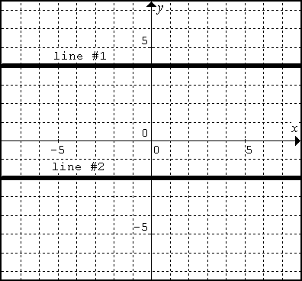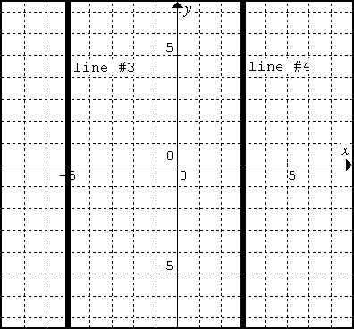Calculate the slope using  of each line.

**Line #1 Line #2**

**Line #3 Line #4**

What can you conclude about the slope of horizontal lines?

What can you conclude about the slope of vertical lines?

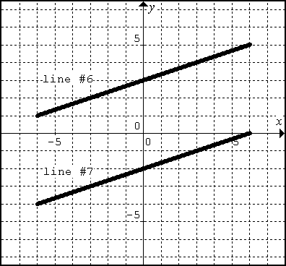2. The following two lines are **PARALLEL**.

Calculate the slope of each line using .

**Line #6 Line #7**

What can you conclude about the slopes of parallel lines?

3. The following graphs have lines that are **PERPENDICULAR**. The relationship is a more difficult to see, so we are completing two examples.

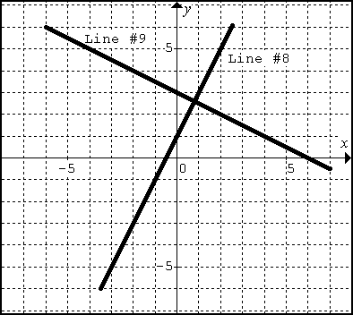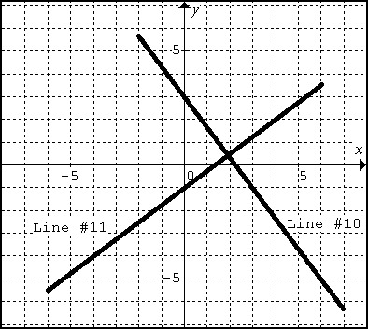 Calculate the slope of each line using .

**Line #8 Line #9**

**Line #10 Line #11**

**What type of relationship do you see between slope 8&9 and slope 10 & 11?**

Lines that are perpendicular have _______________________ slopes.

When you multiply slopes of perpendicular lines together, the result is always __________________.