**Volume of Spheres**

|  |  |
| --- | --- |
| ***Sphere*** |  |

|  |  |
| --- | --- |
| ***Example 1:*** Determine the volume of this sphere in ft3. | ***Example 2:*** Determine the volume of this basketball if the diameter is 30cm.  [http://t0.gstatic.com/images?q=tbn:KTL0quFtkoivfM:http://www.swgc.mun.ca/releases/PublishingImages/basketball.jpg](http://images.google.com/imgres?imgurl=http://www.swgc.mun.ca/releases/PublishingImages/basketball.jpg&imgrefurl=http://www.swgc.mun.ca/releases/Lists/Release%20List/DispForm.aspx?ID=557&usg=__e5OM8QKHSDNaXqkp0X-gvmaBAm0=&h=340&w=340&sz=30&hl=en&start=1&um=1&tbnid=KTL0quFtkoivfM:&tbnh=119&tbnw=119&prev=/images?q=basketball&hl=en&rls=com.microsoft:en-us:IE-SearchBox&rlz=1I7ADSA_en&sa=N&um=1) |
| [http://t3.gstatic.com/images?q=tbn:cid7cVKU8Beq1M:http://www.rockpool.com.au/blog/wp-content/uploads/2009/05/cream-of-chestnut-soup-with-thyme-and-garlic-croutons-1024x742.jpg](http://images.google.com/imgres?imgurl=http://www.rockpool.com.au/blog/wp-content/uploads/2009/05/cream-of-chestnut-soup-with-thyme-and-garlic-croutons-1024x742.jpg&imgrefurl=http://www.rockpool.com.au/blog/category/qantas/&usg=__PY5oJoFUy4SedVNqazWfGten380=&h=742&w=1024&sz=87&hl=en&start=9&um=1&tbnid=cid7cVKU8Beq1M:&tbnh=109&tbnw=150&prev=/images?q=soup+bowl+hemisphere&hl=en&rls=com.microsoft:en-us:IE-SearchBox&rlz=1I7ADSA_en&um=1)***Example 3:*** A soup bowl is in the shape of a hemi-sphere (half sphere). If the bowl is filled to the rim, and has a diameter of 6.5in, how much soup is there? | |

**Surface Area of Spheres**

The surface area of a sphere is **four** times the surface area of one cross section through the centre of the sphere.

A= 4 πr2

[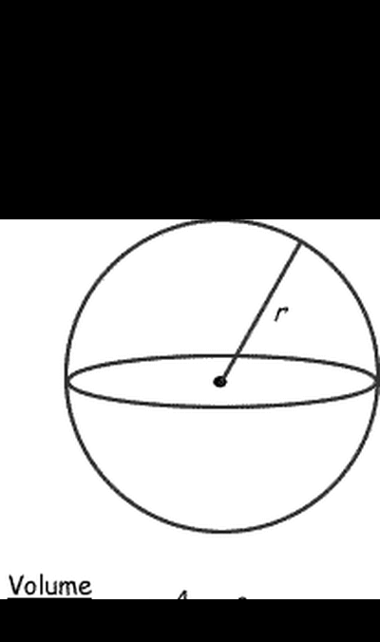](http://z.about.com/d/math/1/0/I/F/spherer.gif)

[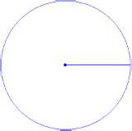](http://www.bing.com/images/search?q=area+of+circle#focal=0f57e6b05369f0571cf2ad8531f7b1e6&furl=http://www.mathsteacher.com.au/year8/ch12_area/07_circle/Image15515.gif)

r

|  |  |
| --- | --- |
| ***Example 1:*** Determine the surface area of the basketball if the diameter is 30cm.  [thumbnail](http://www.bing.com/images/search?q=basketball#focal=d3d95f2ae8ec5ebe1ad3ad0755c9652a&furl=http://www.aitkin.k12.mn.us/sports/RipplesideSports/images/basketball.gif) | ***Example2:*** This foam piece is in the shape of a hemisphere. You plan to paint the entire outer surface. Calculate the surface area if the radius of the circle base is 2.5cm.  [thumbnail](http://www.bing.com/images/search?q=hemishpere#focal=a71c52f44169892b3e21b221109e4817&furl=http://www.bash-design.com/pic/northern_hemisphere_1.jpg) |

**Composite Volume of Prisms, Pyramids, Cylinders, Cones, and Spheres**

Composite shapes are shapes that don’t have a ‘unique’ name, but they are made up of other shapes we are familiar with. An icecream for example, is a cone with a hemisphere.

|  |  |
| --- | --- |
| a. How much icecream is here, assuming the cone is filled with icecream? | b. How much air is inside this empty house, which is made up of a rectangular prism base and a triangular prism roof? |
| c. Pineapple can be bought in sliced rings that look like the sketch provided. If the outer ring has a radius of 7cm and the inner ring has a radius of 3cm, where the height is 1cm in both cases, find the **volume** of this pineapple slice. | d. The following shape is called a frustrum. It is a square-based pyramid with the tip cut off. Find the volume of the frustrum. |
| [http://t0.gstatic.com/images?q=tbn:GyKALbj_HKs-WM:http://midwestsports.typepad.com/.a/6a01157020e7c8970c0120a55c66ed970c-800wi](http://images.google.ca/imgres?imgurl=http://midwestsports.typepad.com/.a/6a01157020e7c8970c0120a55c66ed970c-800wi&imgrefurl=http://www.midwestsportstennisblog-strings.com/2009/08/index.html&usg=__f3R2dNw0LKL6JmjclAhdEvbBMiI=&h=500&w=500&sz=19&hl=en&start=16&um=1&tbnid=GyKALbj_HKs-WM:&tbnh=130&tbnw=130&prev=/images?q=3+tennis+balls+can&hl=en&um=1)e. Three tennis balls are packaged tightly into a cylindrical container. The diameter of one tennis ball is 1.7in. Determine the volume of the space in the can not taken up by the tennis balls. | f. A shipping tube that ships 3-packs of soccerballs is made from a cylindrical center with a hemisphere at each end. Calculate the space that is inside the container. *watch for the units |
| ANSWERS: a. 307.7cm3, b. 158.76m3, c. 125.6cm3, d. 7.7ft3, e. 3.9in3, f. 47,427cm3 | |

|  |  |
| --- | --- |
| h. A rectangular prism has a volume of 603cm3. If a rectangular pyramid has the same base and height as this prism, calculate the volume of the pyramid. | |
| i.A rectangular prism has a volume of 73.6m3. If the length is 8m, the width is 4m, what is the height? | j.A cylinder has a volume of 2009.6cm3. If the radius is 8cm, find the height of this cylinder. |
| ANSWERS: h. 201cm3, i. 2.3m, j. 10cm | |