|  |
| --- |
| **Warm-Up:**  A. The height, *h*, in metres, of a golf ball *t* seconds after Billy Bob hits it with a club is  described by *h* = -5*t*2 + 30*t*. How long is the ball in the air?  C:\Users\Donna\AppData\Local\Microsoft\Windows\Temporary Internet Files\Low\Content.IE5\3DZQMNGZ\j0364350[1].wmf  balls,boys,children,footballs,games,kids,leisure,males,passes,people,persons,recreation,sports,throwing passesB. The height, *h*, in metres, of a football *t* seconds after Billy Bob throws it off the roof of  a building is described by *h* = -5*t*2 + 20*t* + 25. How long is the ball in the air?  view details  C. The height, *h*, in metres, of a baseball *t* seconds after Billy Bob hits it with a bat is  described by *h* = -5*t*2 + 18*t*+1. For how long is the ball in the air? |

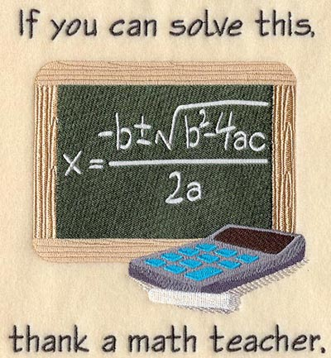

To find the zeros of **a*x*2 + b*x* + c = 0**, you can use this Quadratic Formula:

***Example B from above:* a = \_\_\_\_\_\_\_\_ b = \_\_\_\_\_\_\_\_ c = \_\_\_\_\_\_\_\_**

|  |  |
| --- | --- |
| * substitute the values of a, b, and c into the formula (use brackets!) |  |
| * use your calculator to determine the value under the square root sign |  |
| * take the square root (round to 1 decimal if required) |  |
| * split the equation into 2 equations – one with the ‘+’ and one with the ‘–’ | or |
| * calculate the numerators | or |
| * divide to get your zeros | *t* = \_\_\_\_\_\_\_\_ or *t* = \_\_\_\_\_\_\_\_ |

**Discriminant**

Do you see b2 - 4ac in the formula above? It is called the **Discriminant**, because it can "discriminate" between the possible types of answer:

* when b2 - 4ac is positive, we get two [Real](https://www.mathsisfun.com/numbers/real-numbers.html) roots (The graph has two x-intercepts)
* when it is zero we get just ONE real root (both answers are the same; the graph has one x-intercept)
* when it is negative we get no Real root

1. **-5*x*2 + 18*x* +1 = 0** 2. **-5*x*2 +30*x* = 0**

a = \_\_\_\_\_ b = \_\_\_\_\_ c = \_\_\_\_\_ a = \_\_\_\_\_ b = \_\_\_\_\_ c = \_\_\_\_\_

 

3. **- 3x2 + x – 7 = 0** 4. **x2 – 6x + 9 = 0**

a = \_\_\_\_\_ b = \_\_\_\_\_ c = \_\_\_\_\_ a = \_\_\_\_\_ b = \_\_\_\_\_ c = \_\_\_\_\_

 

5. A paper airplane follows a parabolic path with *h* = -4*t*2 + 11*t* + 3, where *h* is height in metres, and *t*

is time in seconds. Use the quadratic formula to determine how long it takes for the paper airplane to hit the ground. Verify your answer using factoring.

C:\Users\Donna\AppData\Local\Microsoft\Windows\Temporary Internet Files\Low\Content.IE5\YYDIQEQ3\bs00976_[1].wmf

6. The path of one freestyle aerial skier from the top of the kicker (i.e. the ramp) to the landing point can be modeled by *h* = -0.2*d*2 + 2.5*d* + 8, where *h* is the height in metres above the landing point and *d* is the horizontal distance from the kicker.

a. When does the skier land?

b. For how long is the skier above a height of 10 m?

c. Is it possible for the skier to reach a height of 20 m?

6. The length of a rectangular garden is 6 more than the width. The area is 27m2. Use the quadratic formula to determine the dimensions of the garden. Verify your answer using factoring.

x