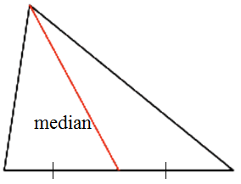
MEDIAN
Median: A line segment from a vertex to the midpoint of the opposite side.

Ex1. Plot and connect the points J(4, 0), O(-5, 2) and B(1, 4) on the grid provided.
Median from J to OB:
- Determine the midpoint of OB algebraically.

- Join J to that midpoint. Calculate the slope of the median. (Remember, you have two points: J (4, 0), and the midpoint at (__, __).

- Determine the equation of the median in y=mx+b form.

Median from O to JB: Median from B to OJ:

The three medians join at the: ______________________________
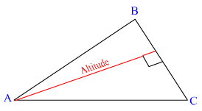
ALTITUDE
Altitude: The perpendicular line segment from a vertex to the line that contains the opposite side.

Ex2. Plot and connect the points B (-4, -2), I (2, 8) and G (8, -2) on the grid provided.
Altitude from B:
1. Determine the slope of IG.

2. Draw a perpendicular line segment that intersects with line IG through B. Determine the slope this altitude. (The opposite reciprocal of the slope of line IG)

3. Determine the equation of this altitude. Remember, you have the slope and one point: slope =___, and B (-4, -2).

Altitude from I: Altitude from G:

The three altitudes join at the: ______________________________
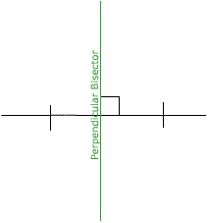
PERPENDICULAR BISECTORS

Perpendicular Bisector: a line (or line segment) that is perpendicular to a segment at its midpoint.

Ex3. Plot and connect the points L(1, 4), A(-5, 2) and P(3, -2) on the grid provided.

Perpendicular Bisector of LA:
1. Determine the midpoint of LA.

2. Determine the slope of LA.

3. Draw a perpendicular line segment through the midpoint of LA. Determine the slope of right bisector. (The opposite reciprocal of the slope of line segment LA)

4. Determine the equation of this perpendicular bisector. Remember, you have the slope and one point: slope = ____ and the midpoint (__, __).

Perpendicular Bisector of AP: Perpendicular Bisector of LP:

The three perpendicular bisectors join at the: ____________________________

