MPM2D-Day III Review: Writing Equations and Standard Form



1. Determine the equation of the line with a slope of  and passes through the point .
2. Determine the equation of the line that passes through the points
   1.  and . b)  and 
3. Determine the equation of the following lines.



a)

b)

**Rules for Standard Form (Another way to write the equation of a line!)**

* Must be in the form A*x* + B*y* + C = 0 where A and B cannot both be zero.
* A must be a whole number (no leading negatives!)
* B, C must be integers.
* A, B, C must not have any factors common to all (can’t all be divided by the same number)

**Examples: Convert the following equations into standard form.**

|  |  |
| --- | --- |
| $y=-3x+2$ | $y=2x+1$ |
| $y=\frac{3}{5}x-5$ | $-3y=2.5x+1$ |
| $y=\frac{1}{2}x-\frac{2}{3}$ | $y=-5x+\frac{1}{3}$ |
| $y+3x=-5x+7y-1$ | $-3y=6x+18$ |

**Extra Practice: Write the equation for the following (in standard form where possible):**

|  |  |
| --- | --- |
| * 1. slope of 4 and passing through (0, 7) | * 1. horizontal and passing through the point   (-5, 18) |
| * 1. and passing through (-1, 4) | * 1. passing through the points (-3, 7) and (2,4) |

e) _____________________

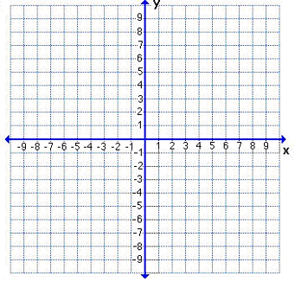

f) _____________________

e)

g) _____________________

f))

g)