Task 1: The Distance Formula
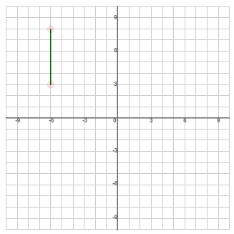
Vertical Line Segments
How long is the line segment on the graph?
units

How can the length be determined using a mathematical calculation instead of counting the number of squares?

Answer: ______________

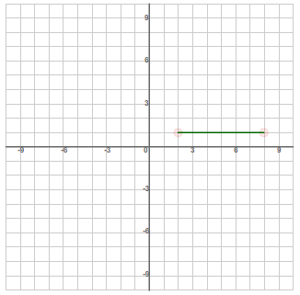
Horizontal Line Segments
How long is the line segment on the graph?
units

How can the length be determined using a mathematical calculation instead of counting the number of squares?

Answer: ______________

Diagonal Line Segments
This line segment is more difficult to determine the length as the number of squares cannot be counted as they are on a diagonal.
First, calculate the vertical line segment
y₂ - y₁ =
c = __
Second, calculate the horizontal line segment
x₂ - x₁ =
X₂ - X₁ ₌ ____
Y₂ - Y₁ ₌ ____

Then, calculate the hypotenuse of the right triangle
c² = a² + b²
=
=
=
=
=
Length of a Line Segment Formula:
length =
Ex. Using the formula, find the length of the line segment D (-3, 5) and E (4,-6).

Task 2: Practice Complete the 5 practice examples in Discovering Distances.

Task 3: Applications
What types of triangles are there?
_______________________ = all sides unequal _______________________ = 2 equal sides

_______________________ = 3 equal sides _______________________ = follows the
Pythagorean Theorem: a² + b² = c², where c is the hypotenuse (the longest side)

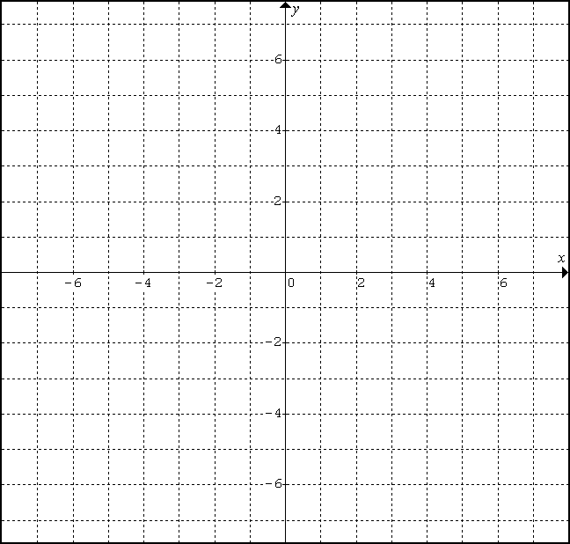
- A triangle has these vertices: D(6, 3), O(-4, 1), G(2, -5).
  - Graph this triangle.
  - Determine the length of each side using the formula. Leave your answers with the square root.
DO =

OG =

DG =

Therefore, ∆DOG is _________________________ (scalene, isosceles, or equilateral?)
- A triangle has these vertices: C(5, -2), A(-3, 6), T(7, 0).

  - Graph this triangle.

  - Use the formula to determine the length of each side. Leave your answers with the square root.

CA =

AT =

CT =

  - Therefore, ∆CAT is _________________________ (scalene, isosceles, or equilateral?)

  - Use the three lengths and the Pythagorean Theorem to determine if ∆CAT is right angled.

  - Determine the slope of each side!
CA = AT = CT =

  - How can you use the slopes to determine whether ∆CAT is right angled?

