A linear relationship can be written in the standard form Ax + By + C = 0 and slope y-intercept form y = mx + b
Graph: 2x - y - 1 = 0

METHOD 1: SLOPE and Y-INTERCEPT | METHOD 2: USING X AND Y - INTERCEPTS
Step1: Rearrange the equation in slope y-intercept form as y = mx + b  Step2: Determine the slope (m) and y-intercept (b)  Slope (m) =__ and y-intercept (b) =__  Step3: Plot the y-intercept first. From there, move right (always) as much as run, then move up if slope + or down if slope - to find a second point and connect with an extended line.  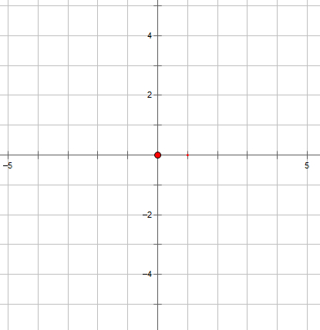 | Step1: To find the x-intercept, let y = 0 and solve for x.  Step2: To find the y-intercept, let x = 0 and solve for y.

METHOD 3: TABLE OF VALUES (y=mx +b)
X | Y = _______ | POINTS
-1 | = | A( , )
0 |  | B( , )
1 |  | C( , )

Ex2. Graph $y=\frac{1}{3}x-1$ using a table of values.

PRACTICE

Graphing
- Graph each equation using a table of values
a) y = 3x – 1 b) y = -2x + 2 c) y = ½ x + 4

- Graph each equation using the slope and y-intercept.
a) y = 2x + 3 b) y = ½x - 2 c) x + y + 1 = 0

- Graph each equation by determining the intercepts.
a) x + y = 4 b) 2x + y = 6 c) 2x – 5y = 10

- Graph each equation using the most suitable method.
a) y = 5x + 2 b) 3x – y = 6 c) y = 3

