Task 1: The Midpoint Formula
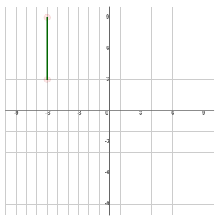
VERTICAL LINE SEGMENTS
What is the midpoint of the line segment AB?
A (-6, 9)
B (-6, 3)
M ( , )

How can the midpoint be determined using a mathematical calculation instead of counting the number of squares?
Answer:

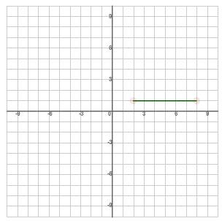
HORIZONTAL LINE SEGMENTS
What is the midpoint of the line segment AB?
A (2, 1)
B (8, 1)
M ( , )

How can the midpoint be determined using a mathematical calculation instead of counting the number of squares?
Answer:

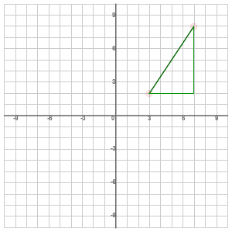
DIAGONAL LINE SEGMENTS
What is the midpoint of the line segment AB?
A (3, 2)
B (7, 8)

First, find the values

Next, find the values

Midpoint = ( , )

Summary:

Formula for the Midpoint of a Line Segment:

midpoint =

midpoint =

Task 2: Practice

Find the Midpoint of the pair of co-ordinates given below:
- $A(3,4)$, $B(-5,2)$

M=$( \frac{x_{1}+x_{2}}{2}, \frac{y_{1}+y_{2}}{2} )$

=$( \frac{ }{2}, \frac{ }{2} )$

=( , ) Therefore:_____________________________________________________

- $P(-7,3)$, $Q(-9,1)$

- $D(\frac{5}{2},-\frac{1}{3})$, $E(\frac{1}{4},\frac{7}{2})$

Task 3: Application

M is the midpoint of line segment UP. The coordinates of U are (-2, 3) and the coordinates of M
are (1, 0). Find the coordinates of P.

