|  |  |  |  |
| --- | --- | --- | --- |
| **CONGRUENT TRIANGLES**  If one shape can become another using Turns, Flips and/or Slides, then the shapes are **Congruent.** In other words, two geometric figures are ***congruent*** when they have exactly the same size and shape.   |  |  |  | | --- | --- | --- | | **ROTATION / TURN**  **rotation.PNG** | **reflection.PNG REFLECTION / FLIP** | **TRANSLATION/SLIDE**  **translation.PNG** |   After any of those transformation (turn, flip or slide), the shape still has the **same size**, **area, angles, and line lengths.**  **The symbol used for congruence is ‘≅’.**  For example, the sentence ‘ΔABC≅ΔDEF’ is read as ‘triangle ABC is congruent to triangle DEF ’ |

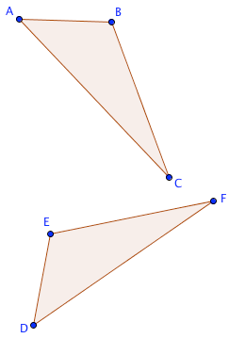**How to Find if Triangles are Congruent**

**CPCTC**: When reporting congruences, you must do so in a way that ‘matches up’ corresponding parts.  
 For example, when you report that ΔABC≅ΔDEF, then all of the following are true:

* ∠A=∠D
* ∠B=∠E
* ∠C=∠F
* AB=DE   ([recall that](http://www.onemathematicalcat.org/Math/Geometry_obj/more_seg_angle.htm) AB represents the distance from AA to BB)
* AC=DF
* BC=EF

This property will be referred to as ‘CPCTC’:  
  
**C**orresponding  **P**arts of  **C**ongruent  **T**riangles are  **C**ongruent.

In this congruence ΔABC≅ΔDEF:  
vertex A corresponds to vertex D.  
Vertex B corresponds to vertex E.  
Vertex C corresponds to vertex F.

The congruence can be reported in any way that preserves this correspondence between the vertices. For example, here are two other correct ways that the congruence could be reported:  
ΔBAC≅ΔEDC   or   ΔCBA≅ΔFED.  
  
However, ΔBAC≅ΔDEF is ***not*** a correct way to report the congruence indicated above.

For more information check <http://www.onemathematicalcat.org/Math/Geometry_obj/triangle_congruence.htm>

**METHODS TO FIND OUT CONGRUENCY**

1. SSS   *(side, side, side)*

|  |  |  |  |  |  |
| --- | --- | --- | --- | --- | --- |
| **SSS TriangleSSS** stands for "side, side, side" and means that we have two triangles with all three sides equal. | |  |  |  |  | | --- | --- | --- | --- | | For example:triangle | is congruent to: |  | triangle | |

## 2. SAS   *(side, angle, side)*

|  |  |  |  |  |
| --- | --- | --- | --- | --- |
| SAS Triangle**SAS** stands for "side, angle, side" and means that we have two triangles where we know two sides and the included angle are equal. | |  |  |  | | --- | --- | --- | | For example:triangle | iscongruent to: | triangle | |

## 3. AAS   *(angle, angle, side)*

|  |  |  |  |  |
| --- | --- | --- | --- | --- |
| AAS Triangle **AAS** stands for "angle, angle, side" and means that we have two triangles where we know two angles and the non-included side are equal. | |  |  |  | | --- | --- | --- | | For example:triangle | iscongruent to: | triangle | |

4. HL   *(hypotenuse, leg)*

|  |
| --- |
| **HL** stands for “Hypotenuse, Leg. This one applies only to [right angled-triangles](https://www.mathsisfun.com/right_angle_triangle.html)!  triangleis congruent to triangle |

## 5. ASA   *(angle, side, angle)*

|  |  |  |  |  |
| --- | --- | --- | --- | --- |
| **ASA TriangleASA** stands for "angle, side, angle" and means that we have two triangles where we know two angles and the included side are equal. | |  |  |  | | --- | --- | --- | | For example:triangle | iscongruent to: | triangle | |

***EXAMPLE #1:***

6cm

Are these triangles congruent? Which congruence   
sufficiency condition applies?

1. State the congruency statement.

i.e. Δ ___ ___ ___ Δ ___ ___ ___

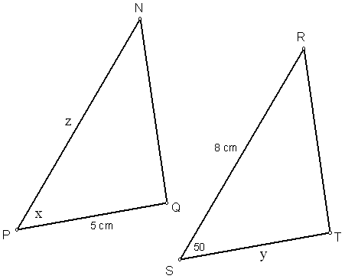***EXAMPLE #2:***   
ΔNPQ  ΔRST. State the values of x, y, and z.



***EXAMPLE #3:***ΔEFG  ΔHJK. State the values of x, y, and z.

***EXAMPLE #4:***   
 a) Show that these triangles are congruent. State the congruency statement, the sufficiency condition, and state all evidence.

b) Determine the values of x, y, and z.