**Slope and Equations of Lines**

**Slope**

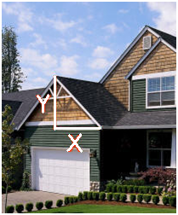The word **slope** (aka: gradient, incline, pitch) is used to describe the measurement of the *steepness* of a straight line or line segment. The higher the slope, the steeper the line is. The slope of a line is a *rate of change.*

Slope is important in many real world situations. For example, a **wheelchair ramp** must be built so that its grade or steepness is small enough that a person in a wheelchair is capable of going up the ramp on his or her own. In addition, **roads** along mountainsides are designed with a small grade so that trucks do not drive out of control. If this happens, the positive slope of a mountain can assist slowing a truck down along an escape ramp.

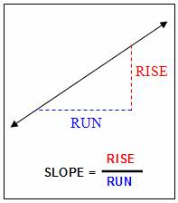

The mathematical symbol for **slope** is ***m***.

*rate   
triangle*

**Ex1. Find** the slope of the line that passes through 

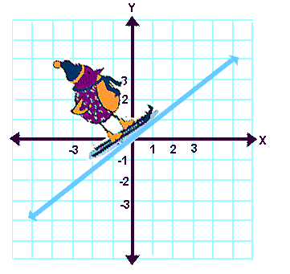 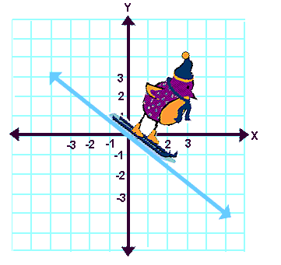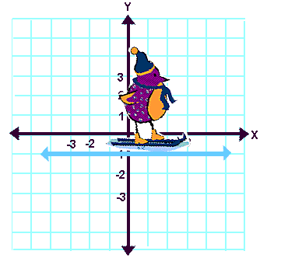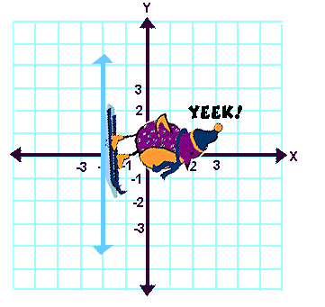

slope is __________ slope is __________ slope is __________ slope is __________

**Equation of the line:**

**Two Formats You Can Start With:**

 ***(slope/y-intercept form)***   ***(slope/point form)***

*m* = _______________ *m* = _______________

*b* = _______________ (*p, q*) = _______________

**End With Either:**

 ***(slope/y-intercept form)*** *or* ***(standard form)***

1. Find the equation of a line in **Standard Form** given a slope of -6 passing through the point
2. Find the equation of the line in **Standard Form** passing through.
3. Find the equation of the line in slope/y_intercept form given a slope of  passing through 
4. Find the equation of the line in y=mx+b that is perpendicular to y =3x+5 passing through W (-2, 4).
5. slope is undefined, passes through (4, -3).
6. Horizontal line passing through (-4, -2).