1. 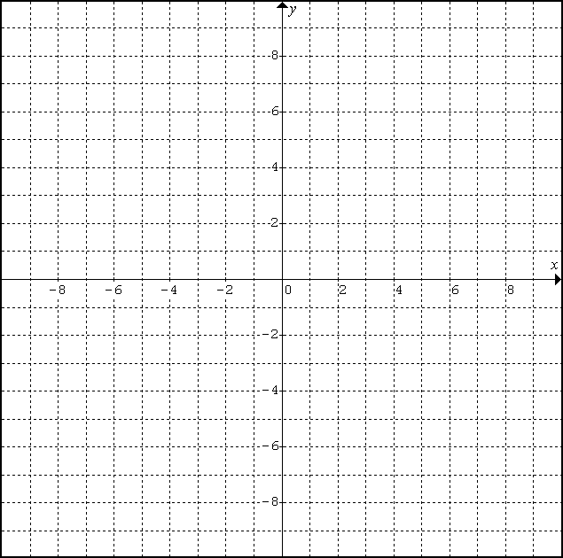Solve the linear system graphically.

y=3x-5

y=-2x+10

1. Solve the linear system graphically.

5x – 2y = 10  
y = –x + 2



1. Solve the linear system graphically.

3x+y=5

-x+3y=-15

1. Determine the number of solutions to the following linear systems.
2. y = 3x – 4 **B)** 5x – 2y – 10 = 0 **C)** y = 2x + 5

y = 3x + 6 x + y = 2 4x – 2y + 10 = 0

1. Solve the linear system using substitution and check your answer.
2. x + 2y = 6 **B)** x + 5y = 11 **C)** x – 7 = y

4x + 3y = 4 4x – y = 2 x – 4 = 4y

1. Solve the linear system using elimination and check your answer.
2. 3x + y = 5 **B)** 3x – 2y = –8 **C)** 3a + b = 12

x – 2y = 11 y – 7 = 3x 2a + 5b = 21

1. Kelly invested his savings of $4800. She invested part in mutual funds, at 9% per year, and the rest in GIC’s at 10% per year. After one year, the interest from the mutual funds was $43 less than the interest from the GIC. How much was invested in each type of investment? (Remember “let” statements)

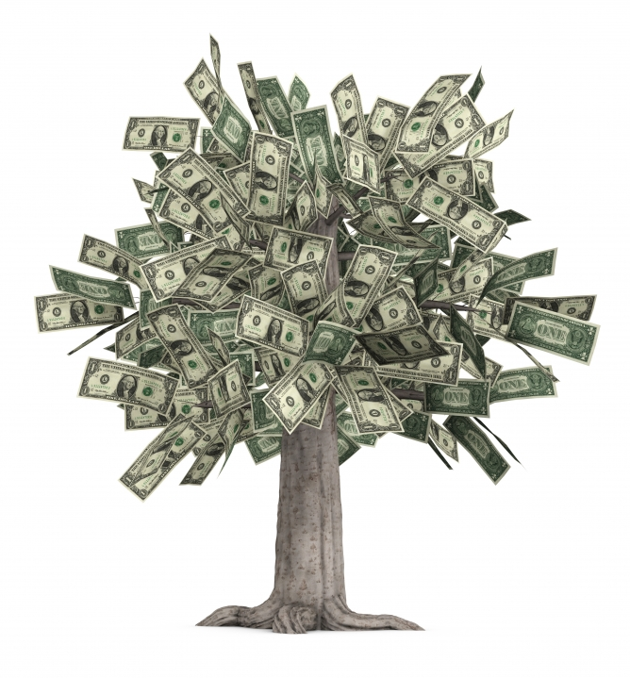

1. Joey gets a summer job as a lab technician, and needs three litres of an 8% saline solution. He has a 5% saline solution and a 9% solution in the lab stock room. How many litres of the 5% and 9% solution should he mix together? (Remember “let” statements)



1. Jayden gets a summer job as a cashier at Canadian Tire. He has a total of $580 in bills at the end of his shift. He has 76 bills, consisting of $5 bills and $10 bills. How many of each type does he have? (Remember “let” statements)

Answers:

1. (3, 4) 2. (2, 0) 3. (3, -4) 4a. 0 b. 1 c. ∞ 5a. (-2, 4) b. (1, 2) c. (8, 1)

6a. (3, -4) b. (-2, 1) c. (3, 3) 7. $2300, $2500 8. 2.25L, 0.75L 9. 36, 40

**Review at home: p. 48 #1, 2, 4-7, 9, 10, 13-17**