Date: ______________________

Date: ____________________
Day 11: Square Roots and Irrational Numbers
To square a number, _____________________________.
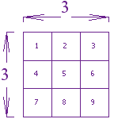
For example, what is 3 squared?

3 squared = $=3×3=9$

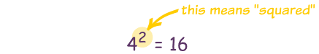
“Squared” is often written as a little 2 like this:

This says: _________________________________________.

Square Roots
A square root _________________________________________.
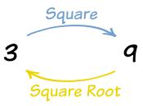
3 squared is 9, so _____________________________________.

The Square Root Symbol
This is the special symbol that means "square root. It is called the radical.
We use it like this:
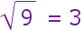
We would say "square root of 9 equals 3"

A square root of a number is a value that can be multiplied by itself to give the original number. A square root of 9 is 3, because when 3 is multiplied by itself we get 9.
It is like asking: What can we multiply by itself to get this?
- But wait a minute! Can't the square root also be −3? Because (−3) × (−3) = 9 too.
- Well the square root of 9 could be −3 or +3.

But when we use the radical symbol √ we only give the positive result.

Perfect Squares
The perfect squares are the squares of the whole numbers:
 | 1 | 2 | 3 | 4 | 5 | 6 | 7 | 8 | 9 | 10 | 11 | 12 | 13 | 14 | 15 | etc
Perfect Squares: | 1 | 4 |  |  |  |  |  |  |  |  |  |  |  |  |  | ...

Ex. 1)
i) $\sqrt{81}$ ii) 2$\sqrt{25}$ iii) - $\sqrt{256}$ iv) $\sqrt{1.44}$

v) $\sqrt{16}$ vi) $\sqrt{25-16}$ *The radical sign is like a bracket.

vii) $\sqrt{-49}$
Note: Numbers like $\sqrt{5}$ and $-\sqrt{17}$ cannot be written as a terminating or repeating decimal. They are called irrational numbers.

Ex. 2) Evaluating to the nearest tenth:

i) $\sqrt{41}$ ii) $-\sqrt{191}$ iii) 4 $\sqrt{2}$ + 3 $\sqrt{5}$ iv) $\frac{4\sqrt{7}}{3}$

Ex. 3) Evaluate for a = 5, b = - 2
$$2.1 \sqrt{a^{2}-2ab+b^{2}}$$

Ex. 4) The area of a square is $98cm^{2}$, what is the length of each side? What is the perimeter?

