1. Solve each of the following using the **quadratic formula**. Round to two decimal places if

necessary.

a.  b. 

c.  d. 

1. Solve each of the following by **factoring**.

a.  b. 

c.  d. 

1. Determine the vertex of each parabola by completing the square:

a. *y* = -3*x*2 – 30*x* – 80 b.  *y* = 4*x*2 – 16*x* + 9

c.  d. 

1. Determine the vertex of each parabola by **averaging the zeros**:

a. *y* = *x*2 + 7*x* – 30 b. 

c.  d. 

1. Find the **x intercepts, vertex**, and **y-intercept** of the quadratic relation below. Graph the relation on the grid provided without using a table of values. Label the axes and curve

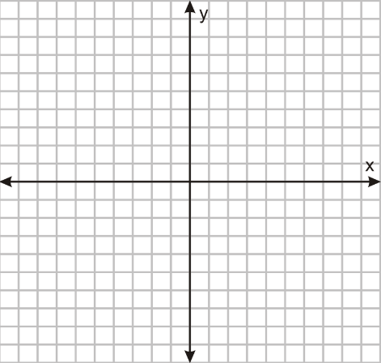

1. Mrs. Mulock hits a golf ball off a tee. Its height above the ground can be approximated by using the equation, where *h* is the height above the ground in metres and *t* is the time in seconds. What is the maximum height of the golf ball? After how many seconds does this occur?
2. Astronauts have performed various experiments while on the moon. In one of their experiments, a projectile was launched and observed. The projectile reached a maximum height of 21 m and landed on the surface of the moon after 3.8 sec. Select the equation for the height, h, in metres, of the projectile after t seconds.

a. h = -5(t – 3.8)2 + 21 b. h = -5 (t – 1.9)2 + 21

c. h = -5 (t + 3.8)2 + 21 d. h = -5 (t + 1.9)2 + 21

1. A water balloon was tossed in the air, and of course Mr. Culhane came up with a quadratic equation that models the total horizontal distance (in metres) covered throughout the flight of the balloon. The equation he came up with was . Determine the horizontal distance covered by this toss by solving the equation above. Round your answer to two decimal places.
2. The product of two consecutive even numbers is 5624. What are the numbers?
3. A rectangular park measures 100 m by 60 m. A path of constant width is to be paved around the perimeter (inside the garden). The mayor wants to be sure that the path does not reduce the area of the grass by more than 10%. What is the maximum allowable width of the path, rounded to the nearest tenth of a metre?
4. If a triangle's height is 22 inches less than two times its base, and has an area of 60 square inches.  What is the height of the triangle? [5 marks]
5. Sherri sells photos of athletes to baseball, basketball, and hockey fans after their games. Her regular price is $10 per photograph, and she usually sells about 30 photographs. Sheri finds that, for each reduction in price of $0.50, she can sell an additional two photographs. At what price will Sherri’s revenue be $150?
6. Determine the equation of the parabola factored form if the x-intercepts are -2 and 6 and the parabola has a maximum of 50.

**Review from the textbook: p. 316 # 4 -8, 10, 13, 14**

**p. 318 # 2 -6, 10, 11, 13, 15**