***Whatcha Need ta Know!***

|  |  |  |
| --- | --- | --- |
| **Triangle Interior Angles** | triangle |  |
| **Vertically Opposite Angles** | Intersecting a circle to show equal opposing  angles |  |
| **Alternate Angles (on Parallel Lines)** | Alternate angles |  |
| **Corresponding Angles (on Parallel Lines)** | Four examples of corresponding angles |  |
| **Co-Interior Angles (on Parallel Lines)** | Co-interior angles |  |

|  |  |  |
| --- | --- | --- |
| **Angle** | **Value** | **Why?** |
| a |  |  |
| b |  |  |
| c |  |  |
| d |  |  |
| e |  |  |

***EG:***

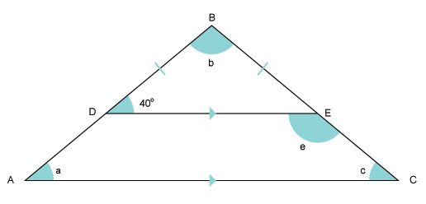

# 

How do you use the Pythagorean Theorem?

## 2 = 2 + 2 2 = 2 - 2

When c is unknown:

When c is unknown:

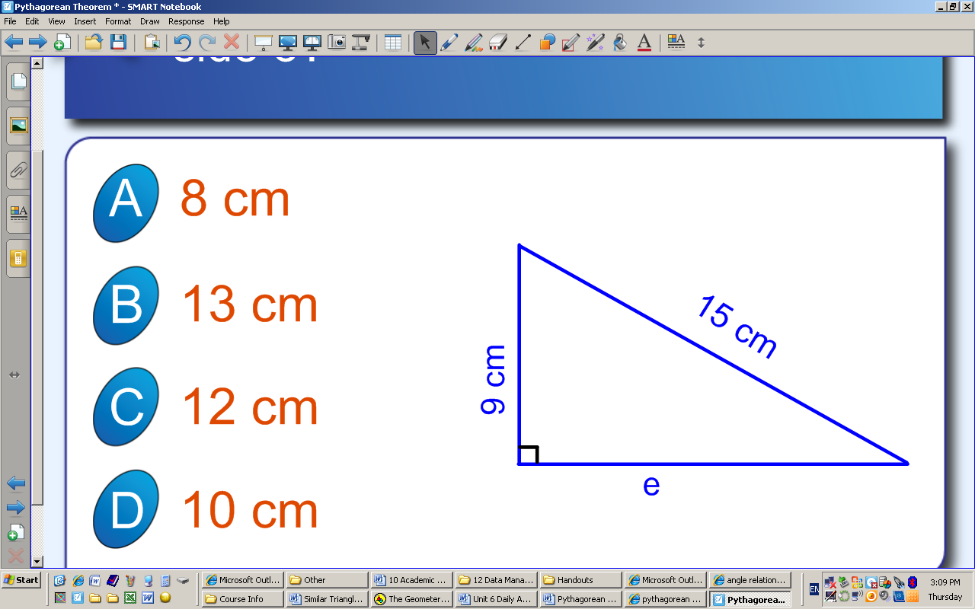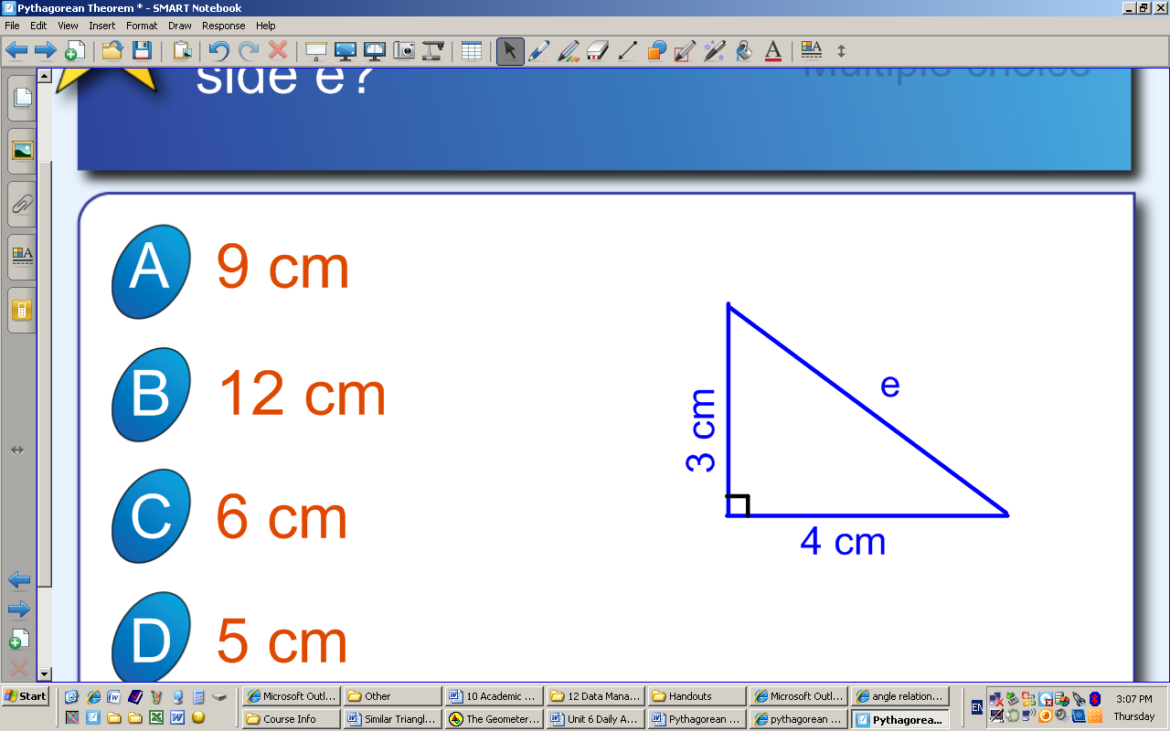

When a or b is unknown:

|  |  |  |
| --- | --- | --- |
| pic3 | solvin33 | proportions_and_similarity_clip_image009 |
|  |  |  |
| solvin36 |  | solvin39 |